**ANALYSIS OF SLOW AND FAST CORONAL MASS EJECTIONS (CMEs) ACROSS SOLAR CYCLES 23 AND 24.**

**ABSTRACT**

This study examines the characteristics of slow and fast Coronal Mass Ejections (CMEs) across solar cycles 23 and 24, focusing on variability in parameters such as speed, angular width, and kinetic energy and mass. Solar cycle 23, characterized by stronger solar activity, showed more variability in fast CMEs, particularly in parameters like angular width. This variability is potentially influenced by a power-law distribution in CME angular width, consistent with previous findings that indicate different expansion behaviors for slow and fast CMEs. This distribution suggests that expansion with propagation may contribute to the variability observed. Notably, slow CMEs showed early-cycle spikes in kinetic energy, while fast CMEs had energy peaks later in each cycle. The study also finds that CME speeds at 20 solar radii (20Rsun) are generally close to their linear speeds, with slight increases in variability for fast CMEs in cycle 24. Fast CMEs also demonstrate a stronger correlation with solar activity metrics across both cycles, indicating greater sensitivity to fluctuations in magnetic field and coronal conditions, especially with hemispheric activity levels. In contrast, slow CMEs exhibit greater variability between the cycles but are less correlated with solar activity, suggesting a stronger influence of internal CME dynamics. These findings emphasize the need for tailored CME propagation models, particularly for weaker solar cycles like cycle 24, where fast CMEs exhibit unique variability patterns. These findings emphasize the need for tailored CME propagation models for weaker solar cycles like cycle 24, where fast CMEs exhibit unique variability patterns.

Keywords: Coronal Mass Ejections (CMEs), solar activity, sunspot number, solar cycle, and solar variability.

**1 INTRODUCTION**

The Sun is a colossal ball of hot plasma that incessantly releases materials – solar wind, solar flares, and CMEs – from its corona into interplanetary space (Schwenn, 2006). The CMEs, distinct from the relatively stable solar wind, pose a significant space weather threat. While CMEs and solar flares stem from the same underlying magnetic processes, not all solar flares are accompanied by CMEs (Yousset, 2012). Of these solar ejections, CMEs possess the highest potential for adverse space weather effects, capable of causing severe disruptions to human technological innovations, if directed toward Earth (Baker et al., 2004). Most solar eruption events are linked to sunspots (Priest and Forbes, 2002). Sunspots' appearance defines the 11-year solar activity cycle (Hathaway, 2015).

The propagation and evolution of CMEs are strongly influenced by solar conditions, including the large-scale magnetic field, solar wind properties, and turbulent energy (Low, 2001; Uga et al., 2024). Among these, the fluctuating magnetic fields in turbulent solar wind can alter the magnetic configuration of CMEs, potentially affecting reconnection processes and the stability of the flux rope (Hu et al., 2013). As CMEs travel through space, they often generate shock waves, and the surrounding turbulence can modify the shock’s strength, compression ratio, and dissipation (Mikić & Lee, 2006). Additionally, turbulence contributes to the heating and acceleration of particles, affecting the energy distribution within the CME and its surrounding plasma (Jensen et al., 2018). The diffusion of CME plasma due to turbulent fluctuations can lead to structural deformation and mixing with the ambient solar wind, influencing the density and coherence of the ejecta. Furthermore, turbulence-induced drag forces can modify the CME’s speed and expansion, either accelerating or decelerating its motion depending on the local solar wind conditions. During stronger cycle (for example, SC23), higher solar activity may lead to a stronger magnetic field, a denser and faster solar wind, and increased turbulence (Gautam et al., 2024), all of which may contribute to more frequent and energetic CMEs. In contrast, the weaker solar cycle (e.g., SC24) may result in a reduced heliospheric magnetic field, lower solar wind pressure, and weaker turbulence, leading to slower and less intense CMEs.

A comprehensive study by Ravishankar et al. (2020) analyzed the kinematics of 28,894 CMEs observed by the Large Angle and Spectrometric Coronagraph (LASCO) aboard the Solar and Heliospheric Observatory (SOHO) from 1996 to mid-2017. The research revealed that fast CMEs exhibit significant initial acceleration, with median and average values of approximately 295 m/s² and 251 m/s², respectively. In contrast, slow CMEs display much weaker initial accelerations, with median and mean values around 18 m/s² and 17 m/s², respectively. The study also found that the significant driving force, likely the Lorentz force, operates up to a distance of about 6 solar radii from the Sun during the first two hours of propagation. Additionally, a notable anti-correlation was observed between the magnitude of initial acceleration and its duration. The residual acceleration, which is the acceleration after the initial phase, ranged from -1,224 to 0 m/s², with a median value of -34 m/s², indicating that CMEs tend to decelerate as they move away from the Sun. Interestingly, the study noted that the residual acceleration was much smaller during solar cycle 24 compared to cycle 23, suggesting variations in CME dynamics across solar cycles.

Further research by Pant et al. (2021) investigated the width distribution of slow and fast CMEs during solar cycles 23 and 24. The study found that the width distributions of these CMEs follow different power-law behaviors, with power-law indices of -1.1 for fast CMEs and -3.7 for slow CMEs. This suggests that fast and slow CMEs may be associated with different processes at their source regions. The analysis also indicated that the width expansion mechanisms of CMEs could vary based on their speed and origin, highlighting the complexity of CME dynamics.

Statistical analyses of CMEs have elucidated distinct differences in the kinematic and geometric parameters of fast and slow CMEs. Fast CMEs are characterized by higher initial accelerations and broader widths, while slow CMEs exhibit weaker accelerations and narrower widths. In Umuogbana & Onuchukwu (2022), Onuchukwu & Umuogbana, (2024), and Onuchukwu & Umuogbana, (2025) we have discussed various classes of CMEs parameters variations across solar cycles (SCs). In this study, we aim to compare CMEs with low linear speeds (Slow CMEs, defined as speeds below 400 km/s) and CMEs with high linear speeds (Fast CMEs, defined as speeds exceeding 400 km/s) across SCs 23 and 24 (Gosling & Manchester, 1994; Schwenn, 2006; Gopalswamy & Davila, 2010 for CME classifications based on speed). Slow CMEs originate from quiescent filaments or large-scale coronal structures that destabilize gradually (Vršnak & Cliver, 2008) while, fast CMEs are associated with energetic events like solar flares and active regions (Yashiro et al., 2004). Fast CMEs compress solar wind, generating shocks that accelerate particles and enhance space weather effects (Gopalswamy, 2006). Slow CMEs interact differently, often merging with the background solar wind, which affects their propagation and evolution (Gopalswamy, 2017).

**2 DATA**

Key CME parameters extracted from the LASCO Catalogue include: CPA, defining the angular position of ejection relative to the solar disk center; Speed at 20Rsun (km/s), critical for assessing CME propagation beyond the Sun; Linear Speed (LS), categorized as slow (≤400 km/s) or fast (>400 km/s) based on established thresholds (Schwenn, 2006); and Mass (kg), derived from white-light coronagraph imaging to quantify ejected plasma (Howard & Tappin, 2009). These metrics collectively enable analysis of CME behavior, including aligning with broader efforts to correlate solar activity cycles (SC 23 and 24) with eruptive phenomena.

**3 DATA ANALYSIS**

We analyzed sunspot numbers (SSNs) and sunspot area in the Northern (SSANH) and Southern (SSASH) Hemispheres for both cycles and performed a yearly averaged analysis over 27 days for both slow and fast CME parameters, aligning with the approximately 27-day period it takes for the Sun to complete a full rotation. We plotted the distributions of these solar parameters, determined the skewness and kurtosis of their distributions, and compared the parameters across the two SCs. We also analyzed the correlations of these parameters with SSN and SSA. The outcomes of this research we believe will be of considerable significance for SC modeling and prediction.

**4. RESULTS**

**4.1 SSN and SSA Analysis**

**Fig 1: Monthly averaged Sunspot Number time series.**

Figure 1 (Onuchukwu & Umuogbana, 2024; Onuchukwu & Umuogbana, 2025) illustrates SSN and Sunspot Area (SSA) variations for Solar Cycles (SCs) 23 and 24, revealing a double-hump pattern in SSNs, consistent with prior studies (Ramesh & Rohimi, 2010; Yoshida, 2014; Christian, 2018). SC 23 peaked in 2000, while SC 24 peaked in 2014, with the latter exhibiting weaker and less symmetric activity, unprecedented in the space age (Singh & Bhargawa, 2017; Petrovay, 2020). The diminished magnitude of SC 24 has prompted speculation about an impending "Grand Solar Minimum," akin to the Little Ice Age (1650–1715).

Monthly SSA plots in Figure 1 highlight pronounced North-South hemispheric asymmetry, particularly in SC 24 (Chowdhury et al., 2013; Li et al., 2008). This systematic asymmetry, observed across cycles, arises from differential polar field reversals, independent hemispheric activity generation driven by differential rotation and meridional circulation (Li et al., 2008; Durant & Wilson, 2002), and weak interhemispheric coupling (Norton & Gallagher, 2010). Such dynamics suggest inherent solar mechanisms rather than random variability (Chowdhury et al., 2013; Li et al., 2008), underscoring the need for further research to unravel the complex drivers of solar activity and their photospheric manifestations.

**4.2 Time Series Plot For Slow And Fast CME Parameters.**

The yearly averaged mean (Fig. 2a) and median (Fig. 2b) time series for SC 23 indicate that the CPA of slow CMEs fluctuates between approximately 140° and 210°, with mean values showing less variability than the median. A similar trend is observed for SC 24, though with more pronounced fluctuations, especially between years 8 and 10. Previous studies by Plunkett et al. (2001) and Cremades et al. (2006) have shown that CMEs tend to move toward the solar equator due to the influence of large-scale solar magnetic fields. This equatorial tendency is evident in both cycles, although SC 24 exhibits more pronounced variations, further emphasizing the complex interplay between CME dynamics and solar magnetic fields.

For fast CMEs, CPA variations do not follow a clear predictive pattern, and there is little resemblance between SC 23 and SC 24. The mean CPA for SC 23 fluctuates between 170° and 238°, while the median ranges from 130° to 270°. In SC 24, the mean CPA remains between 160° to 170°, and the median varies between 130° and 280°. The lack of similarity between the two cycles suggests different underlying solar conditions affecting CME propagation. Fast CMEs exhibit less variability compared to slow CMEs, indicating that they originate from more selective regions on the solar surface. Research by Wang and Colaninno (2014) and Pant et al. (2021) supports these observations, showing that the source regions and propagation directions of CMEs differ based on speed. Fast CMEs, typically originating from active regions, have more concentrated CPAs, while slow CMEs, often associated with quiescent filament eruptions, display a wider CPA distribution. These variations between solar cycles reflect the evolving dynamics of the Sun’s magnetic field over time.

**Fig 2: Yearly Averaged Time Series of CPA for Slow and Fast CMEs (for Fig 2-7, a – Using Yearly Mean Values; b – Using Yearly Median Values)**

2a

2a

**Fig 3: Yearly Averaged Time Series of Linear Speed for Slowand Fast CMEs**

The yearly averaged mean and median LS for slow CMEs in SC 23 peak around year 6 at 300 km/s before declining, while SC 24 follows a similar pattern with a slightly lower peak of 280 km/s. Both cycles exhibit broad peaks, consistent with Gopalswamy et al. (2015), who observed that slow CME speeds peak mid-cycle. Fast CME LS variations show similarity, with SC 23 reaching mean and median peaks of 725 km/s and 625 km/s in year 8, while SC 24 records peaks of 615 km/s and 550 km/s in 2011 (year 3), following the solar cycle (Gopalswamy et al., 2015; Vourlidas et al., 2010).

Pant et al. (2021) found that LS trends for fast and slow CMEs reflect solar activity and magnetic field dynamics (Wang & Colaninno, 2014; Gopalswamy et al., 2015). Fast CMEs, linked to active regions, peak in speed and frequency during solar maximum, while slow CMEs, originating in quiescent regions, are evenly distributed. SC 23 had stronger solar activity, leading to more pronounced differences in CME speeds and frequencies, whereas SC 24’s weaker solar activity resulted in lower speeds and less contrast between peak and quiet periods. These disparities are attributed to SC 24’s weaker solar magnetic field and reduced sunspot numbers.

**Fig 4: Yearly Averaged Time Series of Speed at 20Rsun for Slowand Fast CMEs**

The yearly averaged mean and median speeds at 20Rsun for SC 23 show similar trends, with peak speeds occurring around the 5th and 6th year, reaching up to 400 km/s (Fig. 4a and 4b). SC 24 exhibits a less pronounced peak, with mean speeds just above 350 km/s and a more fluctuating trend, while median values again indicate a lower speed range. Gopalswamy et al. (2015) found that slow CMEs at 20Rsun show speed peaks corresponding to solar activity, aligning with SC 23’s patterns.

For SC 23, both mean and median speeds at 20Rsun show similar variations except in the early and late phases. The average mean speed rises from 550 km/s to 650 km/s between 1990 and 1997, while the average median speed decreases from 600 km/s to 550 km/s between 1996 and 1998. In the late phase (2007–2008), mean speeds rise from 650 km/s to 800 km/s, whereas the median decreases from 550 km/s to 500 km/s before increasing to 600 km/s. SC 24 follows a U-shaped time series, reflecting SC behavior but in reverse—showing a decrease, minimum, increase, and an abrupt drop from 2017 to 2018. The mean speed exhibits a smoother curve at the minimum, while the median is more variable. Gopalswamy et al. (2015) noted that fast CME speeds at 20Rsun peak during solar maximum, following a cyclic pattern with variations between cycles.

**Fig 5: Yearly Averaged Time Series of Mass for Slowand Fast CMEs**

5a

The yearly averaged mean and median CME masses for SC 23 and SC 24 display significant differences (Fig 5a and 5b). For SC 23, the mean CME mass exhibits a notable peak around year 2, reaching up to 1.6 x 1015 kg, followed by a decline. The median values are much lower, indicating a few very massive CMEs skewing the mean. SC 24 shows a similar initial peak but at a much lower value, around 5x1014 kg, and a more gradual decline over the cycle. The median mass values are consistently lower, suggesting a more s Cancer and less massive CME distribution in SC 24. Vourlidas et al. (2010) and Gopalswamy et al. (2015) found that CME mass peaks during solar maximum periods, consistent with the trends seen in SC 23.

CME mass variation for average mean and median for SC 23 are the same. The trend is a descending one with peak events for average mean and median in 1997 and 1998 respectively; which recorded a little less than 4 x 1018 kg and 3 x 1015 kg respectively. For SC 24, the variation of both averages bears semblance too, but with the average mean time series showing a noticeable peak event of 4 x 1018 kg in 2014. Both cycles have different semblance with the solar activity cycle. Gopalswamy et al. (2015) and Vourlidas et al. (2010) found that fast CMEs have higher mass peaks corresponding to solar maximum, consistent with observed trends.

The AW of CMEs in SCs 23 and 24 exhibits a decreasing temporal trend, with SC 23 peaking earlier (~121° at maximum in years 3–4) and displaying broader, more variable AWs compared to SC 24, which peaked later (~61° in year 5) with narrower distributions (Fig. 6). SC 23’s pronounced fluctuations (years 4–6) and higher average AW reflect stronger solar activity and magnetic fields, while SC 24’s subdued AW aligns with its weaker magnetic strength and reduced activity (Gopalswamy et al., 2014; Majumdar et al., 2021). During SC 23’s maximum, AWs ranged 10°–75°, occasionally exceeding 150°, whereas SC 24’s narrower peak (10°–60°) underscores its diminished vigor. These differences highlight AW as a key diagnostic for solar cycle-driven CME morphology and space weather impacts.

Fast CMEs, linked to active regions and solar cycle peaks, exhibit broader AWs than slow CMEs, which originate from quiescent regions and follow steeper power-law distributions, suggesting distinct driving mechanisms. Fast CMEs correlate strongly with solar wind speed and magnetic structures, while slow CMEs show narrower, less dynamic profiles (Gopalswamy et al., 2014; Majumdar et al., 2021). Observational biases, such as projection effects, are mitigated in limb CME studies, where fast events still display larger widths. The contrast in AW distributions between cycles—SC 23’s dynamic range versus SC 24’s constrained spread—emphasizes the role of solar magnetic dynamics in shaping CME properties, critical for modeling solar-terrestrial interactions and predicting space weather phenomena.

**Fig 6: Yearly Averaged Time Series of Angular Width for Slowand Fast CMEs**

Fast CMEs, typically associated with active regions, showed broader AWs than slow CMEs, which are often linked to prominence eruptions or quieter solar regions. During both cycles, the angular widths of fast CMEs were more influenced by the solar wind speed and underlying magnetic structures, while slow CMEs had narrower distributions. Analysis indicates that slow CMEs follow a steeper power-law distribution in width compared to fast CMEs, suggesting a fundamental difference in their driving mechanisms. Fast CMEs also exhibited a closer correlation with solar cycle peaks (see Gopalswamy, et al. 2014; Majumdar et al. 2021). Observational biases like projection effects were reduced when studying limb CMEs (those near the solar limb). For these events, fast CMEs showed a larger angular width than slow CMEs, consistent with the general trend. During the maximum phase of SC 23, the AWs of CMEs predominantly ranged between 10°-75°, with a small fraction exceeding 150°. In SC 24, the AWs peaked more narrowly around 10°-60°, reflecting the cycle's weaker nature. Overall, the angular width distribution of CMEs serves as an important diagnostic tool for understanding solar dynamics and the influence of solar cycles.

**Fig 7: Yearly Averaged Time Series of Kinetic Energy (KE) for Slowand Fast CMEs**

We observed more variability in KE (Fig 7) of slow CMEs in SC 23 with notable peaks around years 3 and 6, while SC 24 presents a more subdued trend. The mean KE for slow CMEs in SC 23 remains consistently higher than in SC 24, with sharper fluctuations throughout the cycle.

**4.3 Regression Analysis**

**4.3.1 Scatter Plots Among CMEs Parameters**

**Table 1 Mean and Median Values of 27-Day Averages for the parameters of Fast and Slow CMEs for SCs 23 and 24**

|  |  |  |  |  |  |  |  |  |
| --- | --- | --- | --- | --- | --- | --- | --- | --- |
| Parameter | SLOW | SLOW | FAST | FAST | SLOW | SLOW | FAST | FAST |
| SC 23 | SC 23 | SC 23 | SC 23 | SC 24 | SC 24 | SC 24 | SC 24 |
| Mean | Median | Mean | Median | Mean | Median | Mean | Median |
| LS (km/s) | 247.5  ±20.3 | 247.9 | 619.8  ±68.4 | 605.1 | 258.2  ±26.0 | 261.0 | 558.6  ±48.2 | 549.6 |
| IS (km/s) | 214.8  ±24.7 | 213.8 | 630.7  ±77.2 | 616.7 | 230.8  ±31.8 | 231.0 | 555.5  ±64.5 | 545.0 |
| FS (km/s) | 275.3  ±26.0 | 277.0 | 615.1  ±68.0 | 603.5 | 278.2  ±27.3 | 279.2 | 574.6  ±45.1 | 573.0 |
| 20Rsun (km/s) | 364.0  ±64.7 | 362.1 | 618.4  ±86.7 | 604.3 | 331.6  ±59.2 | 329.0 | 630.2  ±95.0 | 615.6 |
| Log M (kg) | 14.5  ±0.3 | 14.5 | 15.2  ±0.3 | 15.2 | 14.6  ±0.3 | 14.7 | 15.1  ±0.3 | 15.2 |
| LOG KE (J) | 29.0  ±0.4 | 29.0 | 30.6  ±0.4 | 30.5 | 29.1  ±0.4 | 29.1 | 30.4  ±0.5 | 30.4 |
| AW (Deg) | 36.4  ±10.1 | 35.1 | 59.4  ±21.8 | 56.0 | 40.3  ±14.9 | 42.0 | 64.7  ±28.3 | 59.2 |
| CPA (Deg) | 174.8  ±39.9 | 172.2 | 181.7  ±37.9 | 183.9 | 182.4  ±33.4 | 182.3 | 177.2  ±41.9 | 176.2 |

**Note: LS = Linear Speed of CME; IS = Initial Speed of CME; FS = Final Speed of CME; 20Rsun = Speed of CME at 20 Solar Radii;** **log M = Mass of CME in logarithm; log KE = Kinetic Energy of CME in logarithm; AW = Angular Width** **of CME; CPA = Central Position Angle.**

The mean, variance, and median values from the 27-day average (Table 1) indicate that the average speeds of slow and fast CMEs in SC 23 were generally higher than in SC 24, except at 20Rsun, where SC 24 showed higher values. Fast CMEs exhibited greater mass, kinetic energy, and angular width than slow CMEs, with SC 23 showing broader distributions due to higher solar activity levels. Researchers (Gao & Li, 2008; Gopalswamy et al., 2015, 2020; Mishra & Srivastava, 2020) confirm that CMEs in SC 23 had higher speeds and wider angular widths than SC 24, reflecting more intense solar and heliospheric conditions. The mass and kinetic energy were comparable between the two cycles, though SC 23 had more extreme values due to its stronger activity.

Table 2 presents correlation coefficients (r) and the coefficient of determination (R²) for CME parameters in SCs 23 and 24. The linear speed of CMEs correlated strongly with their initial and final speeds but showed a weak correlation (r≤0.2) with speed at 20Rsun, except for fast CMEs in SC 23. This weak correlation may result from heliospheric drag and solar wind interactions affecting CME speeds beyond the lower corona (Cane et al., 2000; Gopalswamy et al., 2000; Zhang et al., 2004).

**Table 2: The Correlation Coefficients and the Coefficient of Determination Estimated for Various Parameters of Slow and Fast CMEs for SCs 23 and 24.**

|  |  |  |  |  |  |  |  |  |
| --- | --- | --- | --- | --- | --- | --- | --- | --- |
| Parameters | r | r | r | r | R2 | R2 | R2 | R2 |
| SLOW | FAST | SLOW | FAST | SLOW | FAST | SLOW | FAST |
| SC23 | SC 23 | SC24 | SC 24 | SC23 | SC 23 | SC24 | SC24 |
| LS/IS | 0.70 | 0.93 | 0.82 | 0.34 | 0.49 | 0.86 | 0.67 | 0.11 |
| LS/FS | 0.71 | 0.88 | 0.75 | 0.69 | 0.50 | 0.78 | 0.56 | 0.48 |
| LS/20R | 0.19 | 0.64 | 0.15 | 0.10 | 0.04 | 0.41 | 0.02 | 0.01 |
| LS/M | 0.23 | 0.53 | 0.40 | 0.47 | 0.05 | 0.28 | 0.16 | 0.22 |
| LS/KE | 0.35 | 0.69 | 0.51 | 0.64 | 0.12 | 0.48 | 0.26 | 0.41 |
| LS/AW | 0.16 | 0.51 | 0.47 | 0.54 | 0.03 | 0.26 | 0.22 | 0.30 |
| IS/FS | 0.21 | 0.74 | 0.41 | 0.13 | 0.04 | 0.55 | 0.17 | 0.02 |
| IS/20R | -0.24 | 0.47 | -0.18 | -0.14 | 0.06 | 0.23 | 0.03 | 0.02 |
| IS/M | 0.14 | 0.46 | 0.40 | 0.26 | 0.02 | 0.21 | 0.16 | 0.07 |
| IS/KE | 0.28 | 0.62 | 0.52 | 0.31 | 0.08 | 0.39 | 0.27 | 0.10 |
| IS/AW | 0.27 | 0.47 | 0.48 | 0.47 | 0.07 | 0.22 | 0.23 | 0.22 |
| FS/20R | 0.59 | 0.82 | 0.57 | 0.53 | 0.35 | 0.68 | 0.32 | 0.28 |
| FS/M | 0.28 | 0.52 | 0.38 | 0.33 | 0.08 | 0.27 | 0.15 | 0.11 |
| FS/KE | 0.35 | 0.66 | 0.46 | 0.46 | 0.12 | 0.44 | 0.21 | 0.22 |
| FS/AW | 0.06 | 0.48 | 0.36 | 0.20 | 0.00 | 0.23 | 0.13 | 0.04 |
| 20R/M | 0.13 | 0.35 | 0.06 | -0.05 | 0.02 | 0.13 | 0.00 | 0.00 |
| 20R/KE | 0.15 | 0.47 | 0.08 | -0.02 | 0.02 | 0.22 | 0.01 | 0.00 |
| 20R/AW | -0.08 | 0.28 | -0.06 | -0.21 | 0.01 | 0.08 | 0.00 | 0.04 |
| M/KE | 0.93 | 0.91 | 0.94 | 0.93 | 0.87 | 0.84 | 0.88 | 0.86 |
| M/AW | 0.43 | 0.68 | 0.64 | 0.64 | 0.19 | 0.47 | 0.41 | 0.41 |
| KE/AW | 0.50 | 0.72 | 0.71 | 0.66 | 0.25 | 0.52 | 0.51 | 0.44 |

Fig 8 is the scatter plot of 27-day averaged LS against IS, FS, and 20Rsun of slow and fast CMEs for SCs 23 and 24. The slow CMEs follow similar behavior in the variation of IS and FS with LS for SC 23 and 24 with R2. For fast CMEs, SC 23 recorded higher LS, IS, and FS (due to high solar activity) than SC 24 (subdued solar activity). Values of R2 for LS/IS and LS/FS relationship for the fast CMEs during SC 23 were generally higher than R2 for fast CMEs during SC 24 Fig 8e indicates that the speed at 20Rsun does not depend on the measured LS for slow CMEs of both SCs, with R2 . Fig 8f, indicates that for SC 24, the speed at 20Rsun does not depend on the measured LS for fast CMEs in SC24, with R2 , in SC 23 (perhaps due to high solar activity), the speed at 20Rsun does have some dependencies on the measured LS for fast CMEs with R2 .

Fig 9 is the scatter plot of 27-day averaged LS against log Mass (M), KE, and AW of slow and fast CMEs for SCs 23 and 24. The plots indicate that for slow CMEs in SC 23, the LS correlates very weakly with slow CME's mass, kinetic energy, and angular width, but shows some mild correlation with these parameters for slow CMEs in SC 24. For the fast CMEs of SCs 23 and 24, LS seems to influence the observed values of M, KE, and AW, values of R2 – see Table 2. In their articles, Majumdar et al., (2021) and Yashiro et al., (2021) reached similar conclusions.

Fig. 10(a–j) presents scatter plots of the 27-day averaged IS against FS, 20Rsun, logM, logKE), and AW for slow and fast CMEs in SCs 23 and 24. In Figs. 10a–b, IS shows a weak correlation with FS for slow CMEs in both cycles R2=0.04 for SC 23 and R2=0.17 for SC 24. However, for fast CMEs, SC 23 exhibits a strong correlation (R2=0.55), while SC 24 shows no correlation (R2=0.02). In Figs. 10c–d, IS has a weak negative correlation with 20Rsun for most cases ($r≤-0.2$), except for fast CMEs in SC 23, where a mild positive correlation $(r\sim 0.5)$ is observed.

Figs. 10e–h indicate a stronger correlation between IS and mass for fast CMEs in SC 23 $(r\sim 0.5)$ and slow CMEs in SC 24 $(r\sim 0.4)$, while weaker correlations appear in other cases. A similar trend is observed for IS and KE across both cycles. Figs. 10i–j show a positive correlation between IS and AW for both fast and slow CMEs in both cycles. Various studies support these trends and offer slightly differing views on CME parameter correlations (Vourlidas et al., 2010; Vourlidas & Howard, 2006; Mishra et al., 2015; Gopalswamy et al., 2015, 2018; Dissauer et al., 2018; Temmer, 2021).

Fig. 11 presents scatter plots of the 27-day averaged FS against 20Rsun, logKE, logM, and AW for slow and fast CMEs in SCs 23 and 24. FS correlates well with 20Rsun, mass, and kinetic energy for both slow and fast CMEs in both cycles but does not correlate with AW for slow CMEs in SC 23 and fast CMEs in SC 24. However, FS does correlate with AW for fast CMEs in SC 23 and slow CMEs in SC 24. Research supports the correlation between FS and 20Rsun, mass, and kinetic energy, indicating that faster CMEs tend to have greater mass and kinetic energy (Gopalswamy et al., 2014; Vršnak et al., 2016; Pant et al., 2021). The lack of correlation between FS and AW for specific subsets is not explicitly supported in existing literature, though Pant et al. (2021) suggest that slow and fast CMEs follow different expansion mechanisms, which may explain the variation in correlation coefficients. Additionally, Gopalswamy et al. (2014) observed an anomalous expansion of CMEs in SC 24, leading to wider CMEs for a given speed compared to SC 23, which could also contribute to the cycle-dependent relationship between FS and AW.

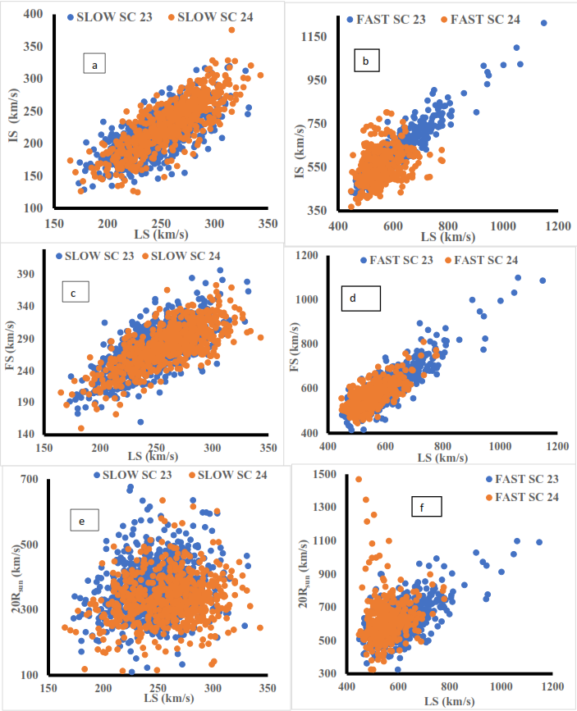

**Fig 8: Scatter plot of 27-day Averaged LS against IS, FS, and 20Rsun of Slow and Fast CMEs for SCs 23 and 24**

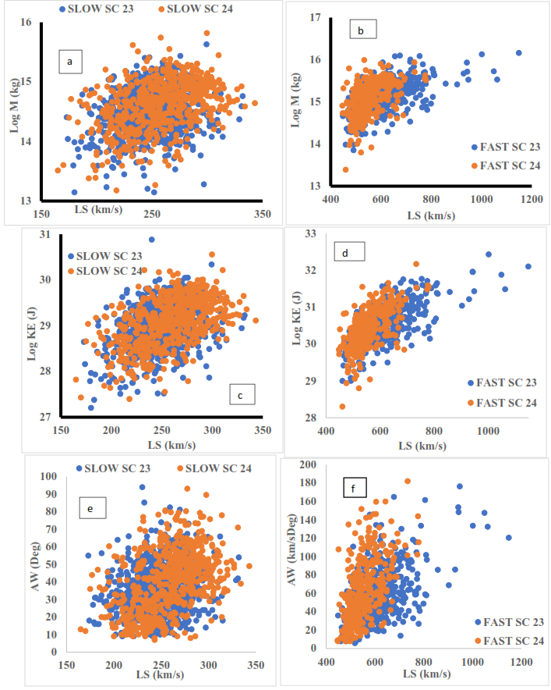

**Fig 9: Scatter plot of 27-day Averaged LS against log Mass (M), log KE, and AW of Slow and Fast CMEs for SCs 23 and 24**

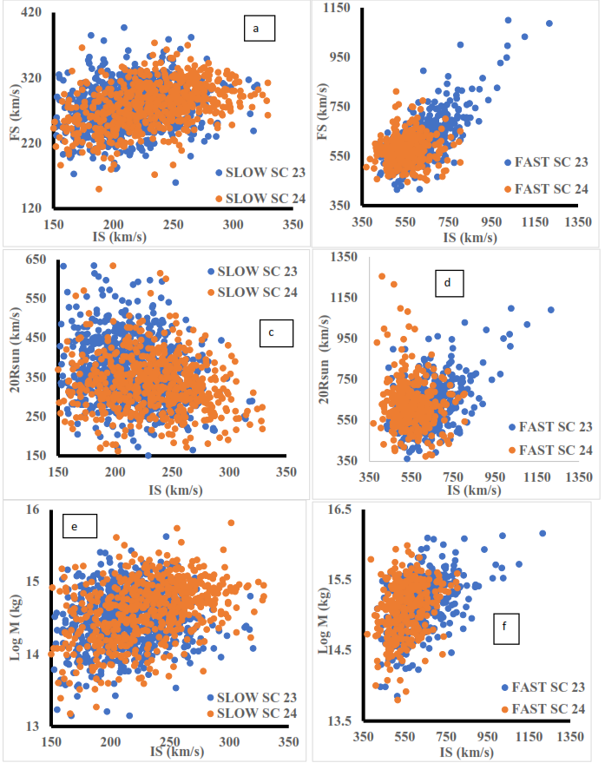

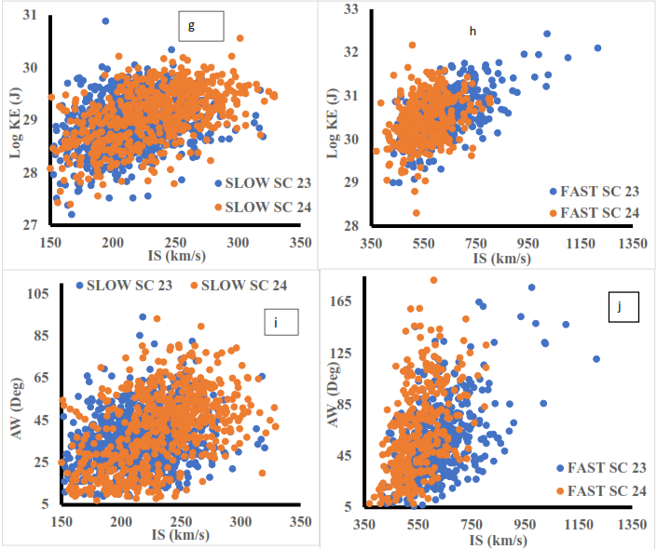

**Fig 10 (a-j): Scatter plots of 27-day Averaged IS against FS, 20Rsun, logM, logKE, and AW of Slow and Fast CMEs for SCs 23 and 24**

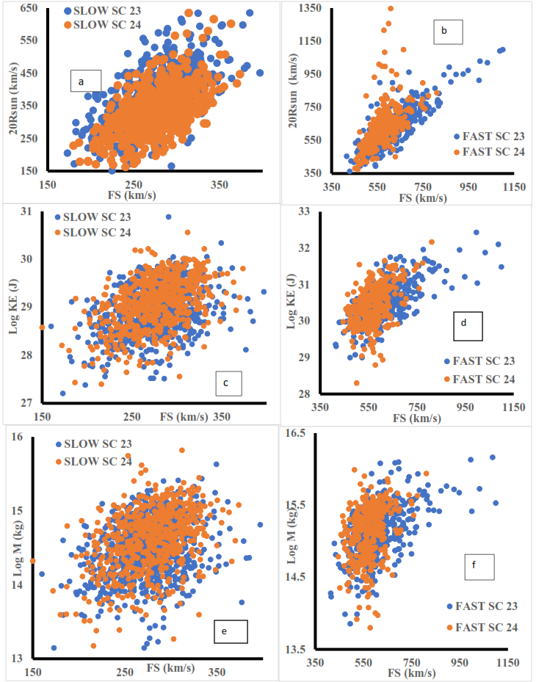

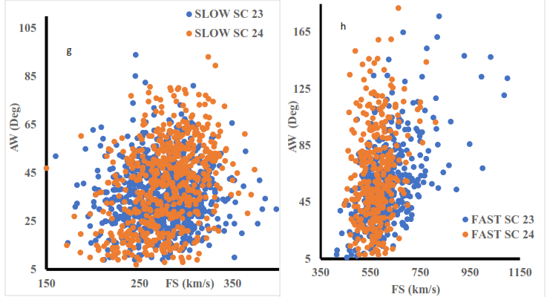

**Fig 11 (a-h): Scatter plots of 27-day Averaged FS against 20Rsun, logKE, logM, and AW of Slow and Fast CMEs for SCs 23 and 24**

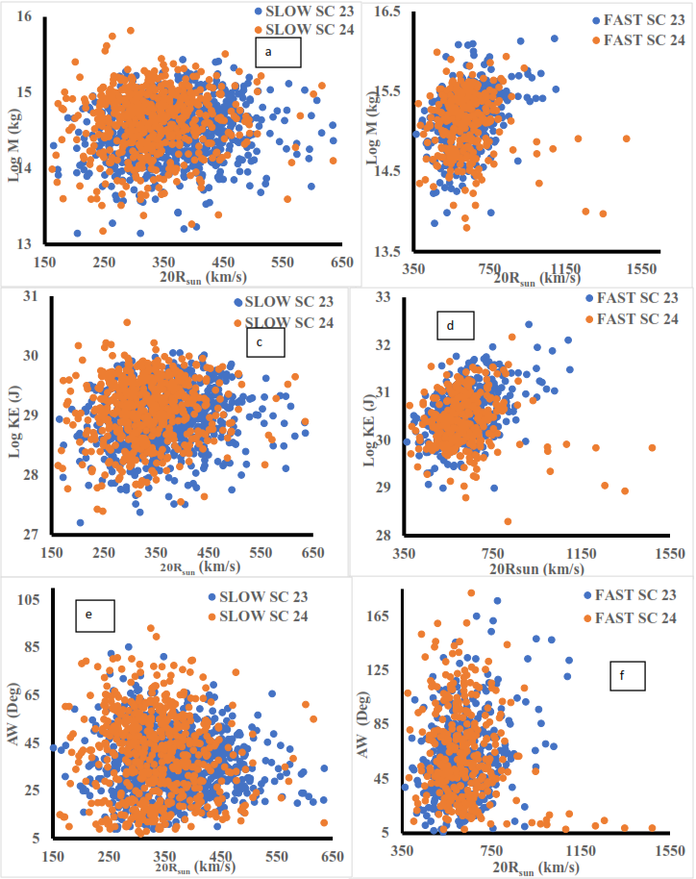

**Fig 12 (a-f): Scatter plots of 27-day Averaged 20Rsun against logKE, logM, and AW)of Slow and Fast CMEs for SCs 23 and 24**

Fig. 12 (a–f) presents scatter plots of 27-day averaged speed at 20Rsun against logKE, logM, and AW for slow and fast CMEs in SCs 23 and 24. Correlation coefficient results from Table 2 indicate no significant correlation between 20Rsun and these parameters for both slow and fast CMEs, except for a mild correlation observed in fast CMEs during SC 23. Existing literature does not extensively report specific correlation coefficients between CME speed at 20Rsun and parameters such as KE, M, and AW for slow and fast CMEs in SCs 23 and 24. However, studies by Gopalswamy et al. (2014) and Compagnino et al. (2017) provide insights into related aspects, such as anomalous CME expansion in SC 24 and statistical relationships among CME properties. While these studies suggest variations in CME behavior across cycles, they do not directly report correlations at 20Rsun. Our study contributes by providing explicit correlation values, highlighting the role of interplanetary medium influences at such large distances from the Sun.

Figs. 13a & 13b show scatter plots of CME logM vs. logKE for slow and fast CMEs in SCs 23 and 24, confirming a strong correlation as KE is derived from mass. Figs. 13c–f depict logM vs. AW and logKE vs. AW, with Table 2 indicating a correlation between CME mass, kinetic energy, and angular width, suggesting that larger AWs correspond to higher mass.

Several studies support this correlation. Gopalswamy et al. (2014) observed that more energetic CMEs tend to have larger AWs, while Zhou et al. (2017) linked CME width to the properties of their source regions, which are indicative of mass. Compagnino et al. (2017) further confirmed a statistical relationship between CME mass and AW across SCs 23 and 24. These findings align with our results, reinforcing that more massive CMEs generally exhibit greater AWs.

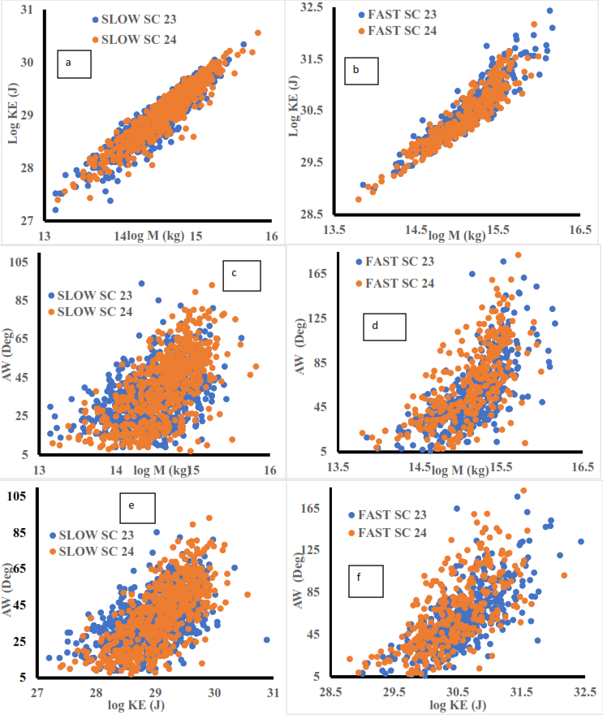

**Fig 13 (a-d): Scatter plots of 27-day Averaged logM against logKE, and AW, and Fig 13 (e-f): Scatter plots of 27-day Averaged logKE against AW of Slow and Fast CMEs for SCs 23 and 24of Slow and Fast CMEs for SCs 23 and 24**

**4.3.2 Scatter Plots Between CMEs Parameters (LS, 20Rsun, AW, M and KE) and SSN, SSANH, SSASH**

**Table 3: Correlation Coefficients and Coefficients of Determination of 27-day Average CME Parameters and SSN, SSANH, SSASH**

|  |  |  |  |  |
| --- | --- | --- | --- | --- |
|  | SLOW | SLOW | FAST | FAST |
|  | SC 23 | SC 24 | SC 23 | SC 24 |
|  | r | r | r | r |
| SSN/LS | 0.70 | 0.45 | 0.53 | 0.34 |
| SSANH/LS | 0.60 | 0.46 | -0.05 | 0.20 |
| SSASH/LS | 0.66 | 0.42 | 0.19 | 0.13 |
| SSN/20Rsun | -0.09 | -0.28 | -0.02 | -0.45 |
| SSANH/20Rsun | -0.15 | -0.18 | 0.21 | -0.26 |
| SSASH/20Rsun | -0.01 | -0.34 | 0.29 | 0.17 |
| SSN/AW | 0.47 | 0.78 | 0.25 | 0.63 |
| SSANH/AW | 0.46 | 0.54 | -0.34 | 0.36 |
| SSASH/AW | 0.37 | 0.73 | -0.32 | -0.02 |
| SSN/M | 0.63 | 0.00 | 0.39 | 0.53 |
| SSANH/M | 0.60 | 0.02 | -0.22 | 0.36 |
| SSASH/M | 0.43 | 0.03 | -0.15 | 0.22 |
| SSN/KE | 0.69 | 0.18 | 0.47 | 0.60 |
| SSANH/KE | 0.64 | 0.18 | 0.15 | 0.37 |
| SSASH/KE | 0.47 | 0.20 | 0.15 | 0.21 |

The correlation analysis of CME parameters with SSN, SSANH, and SSASH for both slow and fast CMEs across SCs 23 and 24 reveals critical differences and similarities in how solar activity influences CME characteristics. Correlation coefficient results are shown in 3 while the plots are shown in Figs 14 to 18

**5 CONCLUSIONS**

This study examines the differences between slow and fast CMEs across SCs 23 and 24, focusing on their variability, distribution, and correlations with solar activity. SC 23 displayed more significant variability and higher occurrences of fast CMEs, which also exhibited broader AWs than slow CMEs. This pattern aligns with the power-law distribution in angular expansion, as Pant et al. (2021) identified, with a power-law exponent of -1.1 for slow CMEs and -3.7 for fast CMEs. The speedier expansion of fast CMEs may be attributed to greater interaction with coronal conditions, causing larger angular width distributions. In both cycles, a peak in the kinetic energy of slow CMEs was observed early in each cycle, while fast CMEs showed kinetic energy spikes in the later stages of each cycle. The speeds and masses of CMEs demonstrated strong correlations in cycle 23 but were notably weaker in cycle 24. The comparison of speeds at 20R and linear speeds shows minimal difference for both CME types, but fast CMEs in solar cycle 24 showed slightly higher variability, possibly due to weaker solar forces in this cycle

Overall, fast CMEs demonstrated stronger correlations with solar activity metrics across both cycles, especially in the context of hemispheric solar activity indicators like sunspot area and sunspot number. This suggests a heightened sensitivity of fast CMEs to changes in coronal magnetic field conditions. Meanwhile, slow CMEs showed greater variability between cycles but a lower correlation with these metrics, indicating that their propagation might be more influenced by internal CME dynamics rather than solar activity fluctuations. This study highlights significant differences in the behavior and distribution of slow and fast CMEs across SCs 23 and 24, with SC 23 exhibiting greater variability, especially in fast CMEs. The power-law distribution of CME angular widths suggests that fast CMEs expand more notably, likely due to interactions with coronal structures, which aligns with findings by Pant et al. (2021) showing distinct power-law exponents for slow and fast CMEs. These exponents reflect different expansion rates with propagation, further differentiating the dynamics of each CME type.

Fast CMEs demonstrated a stronger correlation with solar activity levels, as seen in multiple solar metrics, indicating that they are more sensitive to fluctuations in magnetic field conditions. Conversely, slow CMEs exhibited greater variability between cycles in terms of KE and speed distributions, suggesting that their behavior may be more influenced by internal conditions within the CME itself rather than external solar forces. We observed minimal differences between the LSs of CMEs and their speeds at 20Rsun, suggesting that CMEs reach stable propagation speeds relatively close to the Sun, with fast CMEs in cycle 24 showing slightly higher variability. These insights are crucial for refining predictive models of CME propagation, especially in weaker cycles like cycle 24. The observed differences in CME behavior underscore the importance of dynamic CME models that account for both internal and external forces, enhancing the accuracy of space weather forecasts and contributing to our understanding of CME evolution.

Fast CMEs stem from active regions with strong magnetic fields and impulsive energy release via solar flares, while slow CMEs arise from quiescent prominences through gradual magnetic restructuring (Xu et al., 2019). Propagation dynamics show Lorentz forces dominate fast CME acceleration up to ~4 solar radii and slow CMEs up to 12–50 solar radii, with aerodynamic drag subsequently decelerating fast CMEs and accelerating slow ones to match solar wind speeds (Chen et al., 2019; Gopalswamy et al., 2009). Thermodynamically, fast CMEs expand rapidly, transitioning earlier to isothermal states, whereas slow CMEs undergo gradual expansion (Jin et al., 2023), supported by angular width variations tied to source-region expansion mechanisms (Lamy et al., 2021). These distinctions in drivers, forces, and energy dynamics underpin their space weather impacts. Our results from study of slow and fast CMEs across SCs 23 and 24, generally supports the notion that the origin and modulating factors may be different. Our comprehensive analysis of CME dynamics across SCs 23 and 24 reveals statistically significant distinctions in the origins and modulating factors governing slow and fast CME events, corroborating the hypothesis that these phenomena arise from divergent physical mechanisms.

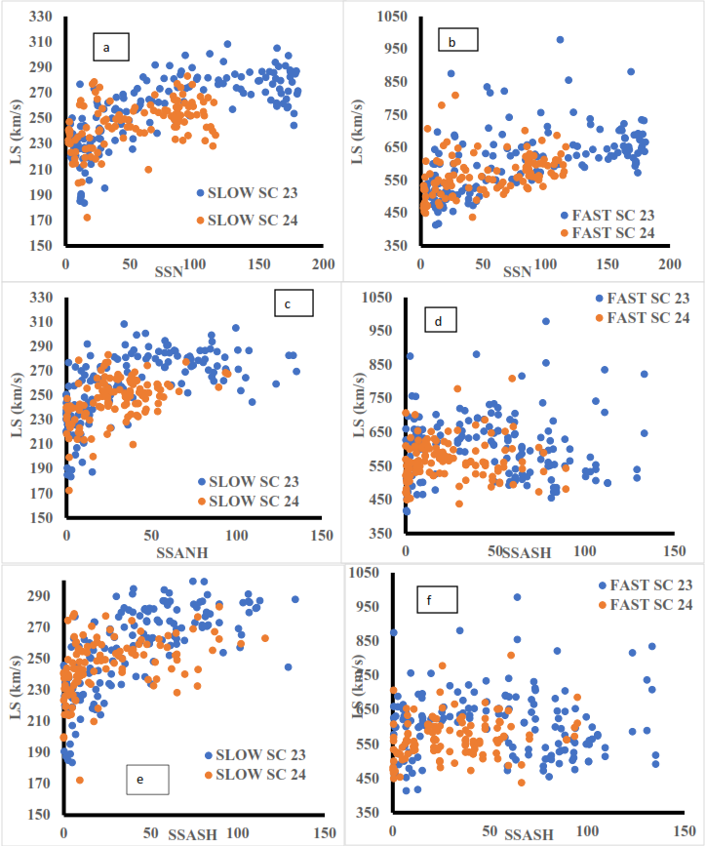

**Fig 14 (a-f): Scatter plots of 27-day Averaged SSN vs LS, SSANH vs LS, and SSASH vs LS of Slow and Fast CMEs for SCs 23 and 24of Slow and Fast CMEs for SCs 23 and 24**

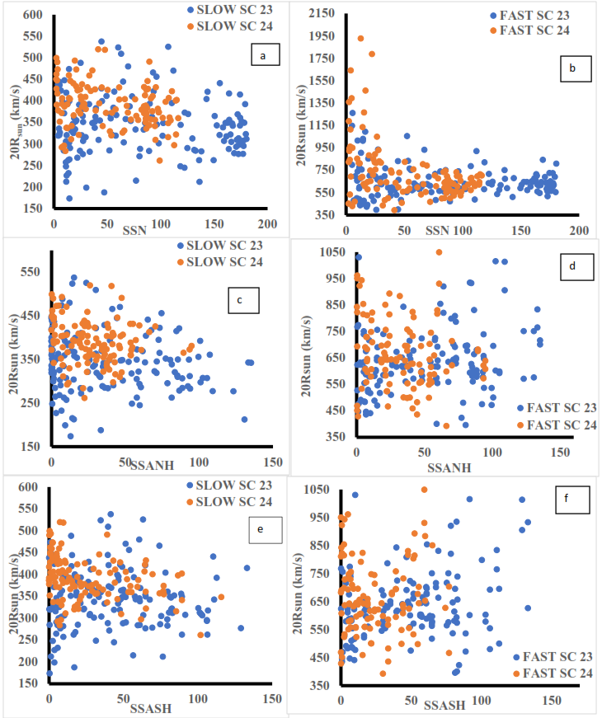

**Fig 15 (a-f): Scatter plots of 27-day Averaged SSN vs 20Rsun, SSANH vs 20Rsunand SSASH vs 20Rsun of Slow and Fast CMEs for SCs 23 and 24 Slow and Fast CMEs for SCs 23 and 24**

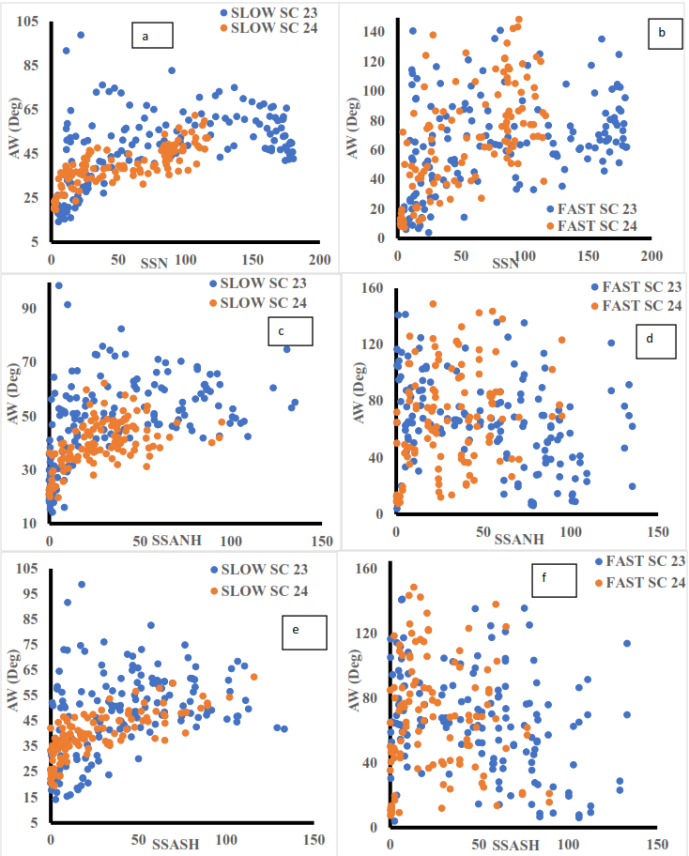

**Fig 16 (a-f): Scatter plots of 27-day Averaged SSN vs AW, SSANH vs AW, and SSASH vs AW of Slow and Fast CMEs for SCs 23 and 24of Slow and Fast CMEs for SCs 23 and 24**

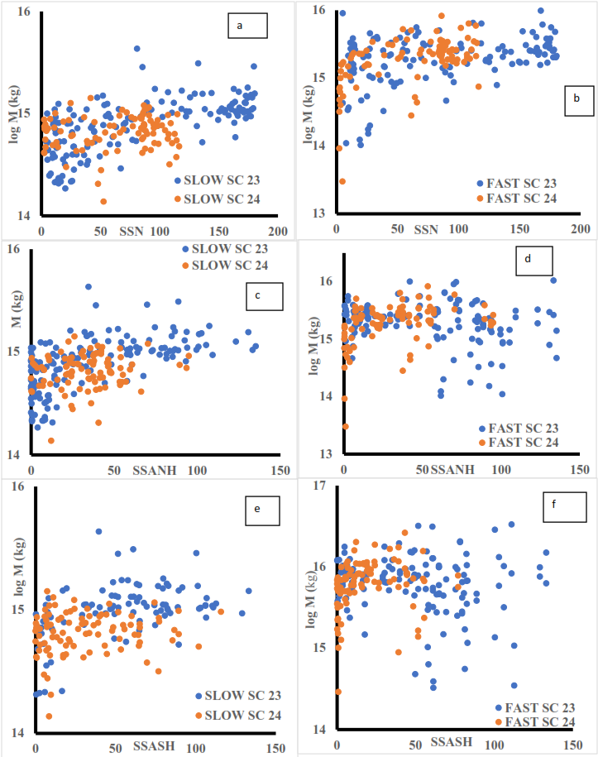

**Fig 17 (a-f): Scatter plots of 27-day Averaged SSN vs log M, SSANH vs log M, and SSASH vs log M of Slow and Fast CMEs for SCs 23 and 24of Slow and Fast CMEs for SCs 23 and 24**

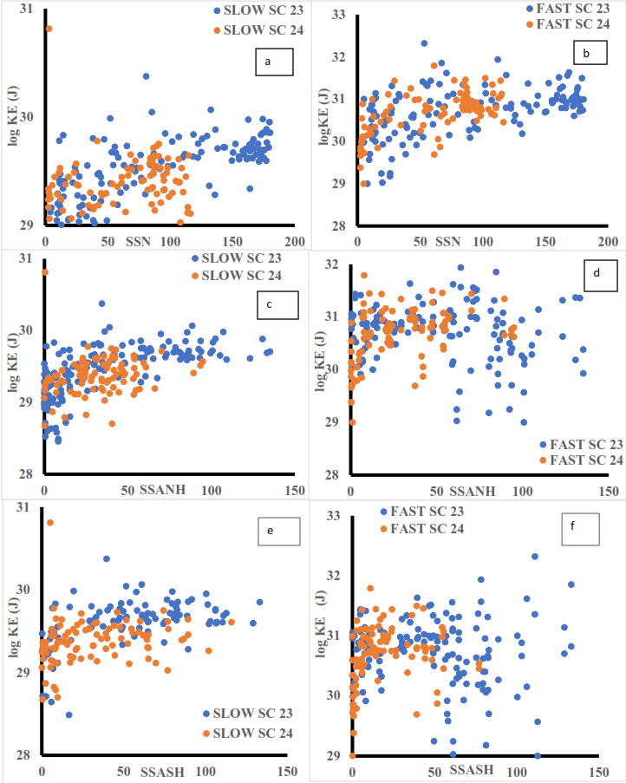

**Fig 18 (a-f): Scatter plots of 27-day Averaged SSN vs log KE, SSANH vs log KE, and SSASH vs log KE of Slow and Fast CMEs for SCs 23 and 24 of Slow and Fast CMEs for SCs 23 and 24**

Disclaimer (Artificial intelligence)

Option 1:

Author(s) hereby declare that NO generative AI technologies such as Large Language Models (ChatGPT, COPILOT, etc.) and text-to-image generators have been used during the writing or editing of this manuscript.

Option 2:

**References:**

**Balmaceda, L. A., et al.** (2010). "The properties of sunspot activity and their influence on the corona and heliosphere." Solar Physics, 262(2), 417-439.

Barker, D.N, Daly E, Daglis I, K, and Panasyuk, M. (2004). Effects of space weather on technology infrastructure; *International journal of research and applications*, 2(2). .

Cane, H. V., Richardson, I. G., & St. Cyr, O. C. (2000). Coronal mass ejections, interplanetary ejecta, and geomagnetic storms. *Geophysical Research Letters*, *27*(21), 3591–3594.

Chen, A. Q., Wang, Y. M., Shen, C., Ye, P. Z., & Zhang, J. (2019). The different roles of Lorentz force and drag force in CME propagation. *The Astrophysical Journal*, *882*(2), 132.

Christian O. C. A statistical analysis of sunspot & CME parameters for the solar cycle 23. *Phys Astron Int J.* 2018;2(4):300-308.

Compagnino, A., Romano, P., & Zuccarello, F. (2017). On the relationship between CME kinematics and the characteristics of the associated flares during Solar Cycles 23 and 24. *Solar Physics, 292*(5), 65.

Cremades, H., Bothmer, V., & Tripathi, D. (2006). Properties of structured coronal mass ejections in solar cycle 23. Advances in Space Research, 38(3), 461-465.

Dissauer, K., Veronig, A. M., Temmer, M., & Podladchikova, T. (2018). Kinematic Properties of CMEs: Impact of Solar Cycle Variation. *Solar Physics*, 293(2), 18. Gao, P. X., & Li, K. J. (2008). Speed distributions of CMEs in cycle 23 at low and high latitudes. *Research in Astronomy and Astrophysics, 8*(2), 145–150.

Gautam, S. P., Adhikari, L., Zank, G. P., Silwal, A., & Zhao, L. (2024). Solar Cycle Dependence of the Turbulence Cascade Rate at 1 au. The Astrophysical Journal, 968(1), 12.

Gopalswamy, N. (2006). Solar sources of space weather and space climate. *Space Science Reviews, 123*(1-3), 303-315.

**Gopalswamy, N.** (2016). "Properties of solar eruptions associated with low-latitude coronal holes." Journal of Geophysical Research: Space Physics, 121(1), 46-55.

Gopalswamy, N., & Davila, J. M. (2010). *Coronal mass ejections: A summary of recent results*. NASA Technical Reports

Gopalswamy, N., Akiyama, S., Yashiro, S., & Xie, H. (2020). Effect of the heliospheric state on CME evolution. *The Astrophysical Journal*, 936(122).

**Gopalswamy, N., et al.** (2010). "The behavior of solar magnetic clouds under different levels of solar activity." Astrophysical Journal, 710(2), 1111-1120.

Gopalswamy, N., Lara, A., Lepping, R. P., Kaiser, M. L., Berdichevsky, D., & St. Cyr, O. C. (2000). Interplanetary acceleration of coronal mass ejections. *Geophysical Research Letters*, *27*(2), 145–148.

Gopalswamy, N., Mäkelä, P., & Yashiro, S. (2014). Power-law distribution of CME widths and their source regions during solar cycles 23 and 24**.** *Frontiers in Astronomy and Space Sciences*.

Gopalswamy, N., Mäkelä, P., Akiyama, S., & Yashiro, S. (2018). The Relation Between the Initial Speed and the Speed at 20 Solar Radii of Coronal Mass Ejections. *Journal of Geophysical Research: Space Physics*, 123(5), 3171–3184

Gopalswamy, N., Xie, H., Mäkelä, P., Yashiro, S., Akiyama, S., & Uddin, W. (2014). Anomalous expansion of coronal mass ejections during Solar Cycle 24 and its space weather implications. *Geophysical Research Letters, 41*(8), 2673–2680.

Gopalswamy, N., Yashiro, S., & Akiyama, S. (2017). Catalog of coronal mass ejections (CMEs) in the STEREO era. *Living Reviews in Solar Physics, 14*(4).

Gopalswamy, N., Yashiro, S., Akiyama, S., & Mäkelä, P. (2015). Coronal mass ejections: Key parameters and solar cycle dependence. *Journal of Atmospheric and Solar-Terrestrial Physics, 123*, 145–156.

Gopalswamy, N., Yashiro, S., Michalek, G., Stenborg, G., Vourlidas, A., Freeland, S., & Howard, R. (2009). A catalog of halo coronal mass ejections from SOHO. *Earth, Moon, and Planets*, *104*(1-4), 295-313.

Gopalswamy, N., Yashiro, S., Xie, H., Mäkelä, P., Michalek, G., Vourlidas, A., & Howard, R. A. (2015). Characteristics of fast and slow CMEs: A study based on solar cycle 23 and 24. *Astrophysical Journal Supplement Series, 221*(1), 17.

Gosling, J. T., & Manchester, W. B. (1994). *Solar Wind and CMEs: An Overview*. Astrophysics Data System.

Hathaway, D. H. (2015). The solar cycle. *Living Reviews in Solar Physics, 12*(4).

Howard, T. A., & Tappin, S. J. (2009). Interplanetary coronal mass ejection observed in the heliosphere: 1. *Review of theory. Space Science Reviews*, 147, 31-54.

Hu, Q., Qiu, J., Dasgupta, B., Khare, A., & Webb, G. M. (2014). Structures of interplanetary magnetic flux ropes and comparison with their solar sources. *The Astrophysical Journal*, *793*(1), 53.

**Janardhan, P., Bisoi, S. K., & Gosain, S.** (2018). "Solar activity and the heliosphere: New perspectives and insights from multi-instrument observations." Journal of Space Weather and Space Climate, 8, A18.

Jensen, E. A., Heiles, C., Wexler, D., Kepley, A. A., Kuiper, T., Bisi, M. M., ... & Vilas, F. (2018). Plasma interactions with the space environment in the acceleration region: Indications of CME-trailing reconnection regions. *The Astrophysical Journal*, *861*(2), 118.

Jin, M., Manchester, W. B., van der Holst, B., Sokolov, I. V., Tóth, G., Vourlidas, A., & Gombosi, T. I. (2023). Thermodynamic evolution of coronal mass ejections in the heliosphere. *The Astrophysical Journal*, *951*(1), 30.

Lamy, P. L., Floyd, O., Quemerais, E., Boclet, B., & Ferron, S. (2021). The angular width distribution of coronal mass ejections: Influence of their speed and source region. *Frontiers in Astronomy and Space Sciences*, *8*, 634358.

Lamy, P. L., Floyd, O., Boclet, B., Wojak, J., Gilardy, H., & Barlyaeva, T. (2019). Coronal mass ejections over Solar Cycles 23 and 24. *Space Science Reviews, 215*(5), 39. <https://doi.org/10.1007/s11214-019-0605-y>

Low, B. C. (2001). Coronal mass ejections, magnetic flux ropes, and solar magnetism. *Journal of Geophysical Research: Space Physics*, *106*(A11), 25141-25163.

Majumdar, S., Mishra, W., & Singh, T. (2021). Investigating width distribution of slow and fast CMEs in solar cycles 23 and 24. <https://arxiv.org/abs/2104.12850>

**Michalek, G., et al.** (2019). "The variability of central position angles in CMEs and their relation to solar activity." Solar Physics, 294(9), 121.

Mikić, Z., & Lee, M. A. (2006). An introduction to theory and models of CMEs, shocks, and solar energetic particles. *Space Science Reviews*, *123*(1), 57-80.

Mishra, W., & Srivastava, N. (2020). Dynamics of coronal mass ejections: A comparison between solar cycles 23 and 24. *Advances in Space Research, 65*(2), 541–555. .

Mishra, W., Srivastava, N., & Chakrabarty, D. (2015). Comparative analysis of Earth-directed CMEs of solar cycle 23 and 24. *Journal of Geophysical Research: Space Physics, 120*(8), 5753–5769.

National Aeronautics and Space Administration. (2012). *What properties of CMEs are most important for space weather?* NASA Technical Reports Server.

Onuchukwu C . C. and Umuogbana A. O. (2024) Comparative Analysis of Coronal Mass Ejections (CMEs) Across Solar Cycles 23 And 24. *A J Planetary Space Sci* 3(3): 135

Onuchukwu C . C. and Umuogbana A. O. (2025). Comparative Study of Accelerating and Decelerating Coronal Mass Ejections (CMEs) Across Solar Cycles 23 and 24. *Asian Basic and Applied Research Journal*, *7*(1), 1–24.

Pant, V., Datta, A., & Banerjee, D. (2021). Investigation of CME width expansion during Solar Cycle 24 and its implications on Earth-directed CMEs. *Solar Physics, 296*(4), 61.

Pant, V., Kilpua, E. K. J., & Vourlidas, A. (2021). Width distribution of slow and fast coronal mass ejections: A statistical study. <https://arxiv.org/abs/2104.12850>

Pant, V., Majumdar, S., Patel, R., Chauhan, A., Banerjee, D., & Gopalswamy, N. (2021). Investigating Width Distribution of Slow and Fast CMEs in Solar Cycles 23 and 24. Frontiers in Astronomy and Space Sciences, 8, Article 634358.

**Petrie, G. J. D.** (2015). "Solar cycle-dependent trends in CME energy and dynamics." Living Reviews in Solar Physics, 12(1), 5.

Petrovay, K. (2020). Solar cycle prediction. *Living Reviews in Solar Physics, 17*(2).

Plunkett, S. P., Thompson, B. J., St. Cyr, O. C., Howard, R. A., Michels, D. J., Tappin, S. J., Schwenn, R., & Lamy, P. (2001). CME Propagation in the Corona and its Relation to the Large-Scale Solar Magnetic Field. *Journal of Geophysical Research: Space Physics,* 106(A12), 25277-25294.

Priest, E. R., & Forbes, T. G. (2002). The magnetic nature of solar flares. *Astronomy and Astrophysics Review, 10*, 313-377.

Ravishankar, V., Kilpua, E. K. J., Vourlidas, A., Papaioannou, A., & Crosby, N. B. (2020). Statistical analysis of the kinematics of coronal mass ejections observed by SOHO/LASCO during solar cycles 23 and 24. <https://arxiv.org/abs/2010.02682>

Schwenn, R. (2006). Space weather: The solar perspective. *Living Reviews in Solar Physics, 3*(2).

Solar and Heliospheric Observatory (SOHO) LASCO CME Catalog. (2017). Statistical analysis of CMEs during solar cycles 23 and 24. *Transactions on Science Journal*.

Temmer, M. (2021). Space weather: The solar perspective. *Living Reviews in Solar Physics, 18*(1), 1–69.

Uga, C. I., Gautam, S. P., & Seba, E. B. (2024). TEC disturbances caused by CME-triggered geomagnetic storm of September 6–9, 2017. *Heliyon*, *10*(10).

Umuogbana A. O., & Onuchukwu C. C. (2022), Coronal mass ejection and solar activity for cycles 23 and 24; a comparative analysis of observational parameters. *Phys Astron Int J.* 2022;6(2):56-60.

Vourlidas, A., & Howard, R. A. (2006). The proper treatment of coronal mass ejection mass calculations. *The Astrophysical Journal, 642*(2), 1216–1221.

Vourlidas, A., Howard, R. A., Esfandiari, E., Patsourakos, S., Yashiro, S., & Michalek, G. (2010). Comprehensive analysis of coronal mass ejection mass and energy properties over a full solar cycle. The Astrophysical Journal, 722(2), 1522-1538.

Vršnak, B., & Cliver, E. W. (2008). Origin of coronal shockwaves. *Solar physics, 253* (1-2), .

**Vršnak, B., et al.** (2007). "The role of sunspot number and coronal magnetic field structure in CME energetics." Solar Physics, 244(1), 25-39.

Vršnak, B., Magdalenić, J., Aurass, H., & Mann, G. (2004). Band-splitting of coronal and interplanetary type II bursts. *Astronomy & Astrophysics, 426*(1), 249–258.

Vršnak, B., Žic, T., Dumbović, M., & Sudar, D. (2016). Kinematics of coronal mass ejections—final speeds and energy relationships. *Astrophysical Journal, 828*(2), 85.

Wang, Y. M., & Colaninno, R. (2014). Are Halo Coronal Mass Ejections Special? *The Astrophysical Journal, 784*(2), L27.

Xu, A., Wang, R., Liu, L., Shen, C., & Hu, H. (2019). Difference of source regions between fast and slow coronal mass ejections. *Publications of the Astronomical Society of Australia*, *36*, e029.

Yashiro, S., Aarnio, A., & Gopalswamy, N. (2021). Correlations between CME parameters and sunspot activity. <https://arxiv.org/abs/1112.5560>

Yashiro, S., Gopalswamy, N., Michalek, G., St. Cyr, O. C., Plunkett, S. P., Rich, N. R., & Howard, R. A. (2004). A catalog of white light coronal mass ejections observed by the SOHO spacecraft. *Journal of Geophysical Research: Space Physics*, 109(A7).

Yoshida, A. (2014). Difference between even and odd numbered cycles in the predictability of solar activity and prediction of the amplitude of cycle 25: *Annales Geophysicae* 32(8): 1035-1042.

Youssef M. (2012). On the relationship between the CMEs and the solar flares; NRIAG Journal of Astrophysical Geophysics, 1(2):

Zhang, J., Dere, K. P., Howard, R. A., & Bothmer, V. (2004). A statistical study of the kinematic evolution of coronal mass ejections. *The Astrophysical Journal*, *604*(1), 420–432.

Zhou, Z., Cheng, X., Zhang, J., Wang, Y., & Poomvises, W. (2017). Statistical study of solar active regions that produce coronal mass ejections with and without eruptive flares. *The Astrophysical Journal, 849*(1), 79.