A MARKOV CHAIN MODEL FOR THE ANALYSIS, PREDICTION AND COMPARISON OF STOCK EXCHANGE MARKETS

**ABSTRACT**

Stock Exchange Markets are part of the general indicators of the state of an economy, and are usually characterized by randomness and volatility. Several methods have been developed for the analysis of such markets so as to explain and perhaps, predict their long run behavior. These methods are either deterministic or stochastic in approach. This study was intended to analyze the price movements in three selected stock Markets and establish a long-term pattern for their stability and volatility. Data for the study were collected from stock reports for 102 consecutive trading days for the stock markets. The strength and direction of volatility was utilized to define five states of the system, and transition probabilities between states were computed intuitively from available data. The data were then transformed into a 5-state Markov Chain process and analyzed as a transition probability scheme. The stochastic features of Markov Chains were then utilized to compute limiting distributions for the system. Results of analysis established the comparative stability and volatility indices of each of the markets, and this was subsequently used to predict expected outcomes in the short run. The choice of the three exchange markets for this study was informed primarily by the strategic regional importance and size of their capitalizations. Time Series graphical analysis were also employed for further illustration.

**KEYWORDS**

Stock exchange markets, transition probability matrix, stability and volatility indices.

**1.0 Introduction**

A time series is a set of observations or an arrangement of statistical data in accordance with time of occurrence, taken at specific times at nearly equal intervals. The numerical data which is given at different points of time, and which represents the set of observations is known as time series. According to Jose (2022), the goal of time series analysis is to extrapolate some dynamic patterns in a data set for the purpose of prediction of future observations. Linear modeling is one of the primary tools that can be used to establish patterns and parameters from the dynamics of a time series. However, the applications and challenges associated with linear models are discussed in Onyemarin *et al* (2023) and Osemeke *et al* (2024).

According Das (2024), a Markov analysis is a process in which the future behavior of the system depends only on the present and not on its past history. It is a probabilistic process in which an object moves from one state to another at discrete time intervals, and that relies on the current information to predict future outcomes. Both time series and markov chains are statistical models for explaining economic phenomena. Classical mathematical models also exhibit flexibility that enhance their adaptability. Epidemiological models have been used extensively to simulate and predict the course and effect of intervention programmes on the dynamics of a disease. For instance, Aghanenu et al. (2022) simulated the effect of imperfect vaccines on the spread of COVID-19 in Nigeria, while Urumese and Igabari (2023) investigated the impact of community lockdown alongside social distancing on the spread of the pandemic. Furthermore, in Ohwojeheri et al (2024), a compartmentalized epidemiological model was adapted to explain the spread of social diseases such as poverty and crime. Such adaptations of mathematical and statistical models have been relatively efficient in explaining and providing strategies to minimize the undesirable effects of the associated vices.

On its own, the Stock Exchange Market is an organized and regulated financial market where securities like bonds, notes and shares are traded at prices dictated by forces of demand and supply. Its analysis and understanding becomes necessary as it plays a vital role in the growth of key sectors of an economy. It also serves as a measurement tool that can quantify the stability of an economy. A rising index or consistent growth in the index is the sign of growing economy, while a falling index or high fluctuations in index gives the impression of instability in an economy. Typically, stock market indices are the performance indicators for the entire market. They act as barometers, which enable us to get an idea about the performance of the entire market in general. A healthy stock exchange market is a healthy economy. Typically, stock market indices are the performance indicators for the entire market. They act as barometers, which enable us to get an idea about the performance of the entire market in general. A healthy stock exchange market is a healthy economy.

Stock market indices around the globe has always fluctuated in ways that make markets difficult to predict. There are two broad types of investors in stock markets. The bullish investor is one who invests with the expectations that stock prices will rise, while a bearish investor assumes that financial market conditions are not conducive for gains and hence trades stock with caution. Both types of investors want to take advantage of their understanding of the movement of stock prices to maximize profits from investments.

The Standard & Poor's 500 (commonly abbreviated as S & P 500), is an American Stock market index based on the market capitalization of 500 large companies. It was estab­lished in 19th century and was bought by McGraw - Hill Companies in 1966. The S & P 500 index is widely accepted because it is independent and it is a market-value-weighted index. FTSE 100 is one of the indices maintained by the Financial Times Stock Exchange (FTSE) Group, a company which is owned by the London Stock Exchange and the Financial Times of London. It is among the popular the indices maintained by the FTSE Group, and it consists of the largest 100 qualifying United Kingdom (UK) companies by full market value. The Nigerian Stock Exchange (NSE) is a Nigeria owned company which offers a wide range of products and powers the growth of one of Africa's largest economies.

The choice of Stock indices of NSE, FTSE 100 and S & P 500 was informed primarily by the strategic regional importance and size of their market capitalization.

The aim of this study was to analyze and create a long-term pattern out of the randomness and volatility of the stock exchange market values with sample data from S & P 500, FTSE 100 and the Nigeria Stock Exchange (NSE). An analytic approach that employed the stochastic features of Markov Chains and transition probabilities on a deterministic data was adopted. Precisely, this research was intended to provide a Time Series graphical analysis of the three markets, represent the stock market movement as a Markov chain, obtain the steady state of each market and use the steady state matrix to compare the stability of the three markets.

**2.0 Literature Review**

Stochastic models have been used by many researchers to predict and analyze stock market behaviour at different times. Adekunle and Eboigbe (2021) used the Markovian model to investigate the stock price movement of quoted Nigerian Oil and Gas firms. The study obtained and analyzed as a time series data of the daily closing share prices over a given period of time. It used a 3-state transition probability matrix to establish first order stationarity and to obtain the steady state. Sultan et al (2019) proposed a first order time homogeneous Markov Chain model for trend prediction of closing share prices in Pakistan’s stock market. The study projected share volatility as a stochastic process with markovian property, and used a 3-state probability matrix to estimate the steady state behaviour of the share prices. Furthermore, Agbam and Udo (2020) applied Markov Chain to model and forecast the trend of Dangote Cement shares at the Nigeria Stock Exchange. The study used secondary data to derive a 3-state transition matrix and provide a limiting distribution for the price movements

In the same vein, Tharshan and Arivalzahan (2018) applied the Markov model to provide a discrete time stochastic model for the analysis of stock market volume. It was able to establish the steady state distribution as well as the expected number of transitions. Other studies in this field include the works of Lakshmi and Manoj (2020) which adopted the memoryless property of Markov processes to predict and compare the performance of five prominent stocks in oil and gas sector in India. Also, the work of Bhusal (2018) used Markov Chain model to forecast the behaviour of Nepal Stock Exchange index. The randomness feature of the indices were exploited to derived the steady state probabilities. Aparna and Sarat (2015) attempted to analyze the behaviour of stock price of State Bank of India, one of the leading commercial bank of India. The study covered a time period of 1,035 stock trading days. Secondary data on daily closing price of shares were collected from Historical price of share-Yahoo Finance. The paper investigated the long term behaviour of the shares, expected number of visits to a particular state, and expected first reaching time of different states. Markov Chain model was used to analyze and predict the stock behaviour considering three different states, classified as ‘up’ (when the share price increases), or ‘down’ (when the share price decreases) or ‘remain the same’ (when share price remains unchanged). The study computed the number of transitions from one state to another and developed the transition probability matrix. Result showed that regardless of bank’s current share price, steady state probabilities of the states ‘up’, ‘down’ and ‘remain same’ for SBI were 0.4699, 0.4981 and 0.0319 respectively. It also observed that if the closing value of SBI share is in the state ‘up’ in day one, then it can be expected to return to the same state as from the third day. Onwukwe and Samson (2014) examined the long run behaviour of the closing prices of shares of eight Nigerian banks using Markov chain model. They computed the limiting distribution, transition probability matrix and found that despite of the current situation in the market there is a hope for Nigerian bank stocks. They posited that the results derived from the study will be useful to investors, intending investors and the other relevant stakeholders in the stock market. Otieno et al (2015) applied Markov chain to model and forecast the trend of Safaricom shares trading in Nairobi Securities Exchange of Kenya. They assumed an initial state vector, computed the transition probability matrix and used them to predict the future state of share prices accurately. The work also provided the long-term behaviour of the share prices. Moreover Zhou (2014) was another study that used the Weighted Markov chain to forecast future prices of trading stock.

The opening stock price of National Stock Exchange NIFTY-50 of India was studied and analyzed via Markov chain by Waikhom et al (2017). The study predicted the prompt future change in opening stock price and computed a steady state transition probability matrix, based on which it was concluded that in the long run, the probability that the change in opening stock price of National Stock Exchange NIFTY 50 of India at a specific day was predictable from the previous day. Vasanthi et al (2011) tried to predict the stock index trend of various global stock indices using Markov Chain Analysis. This work used a First Order Markov Chain Model and applied it to indices of various stock exchanges round the globe and constructed a transition probability matrix from the past behaviour of the system. They showed that the transition probability matrix in conjunction with the probability values of the present state of the system can be used to determine the probabilities of the next state. The study covered the American stock market (DJIA, S &P 500), European Markets (FTSE, FTSH), Australian market (AUSTA (3RD), China (SSE ), South East Asian markets (Hang Seng), Pakistan (KSE) and India (BSE, NSE) in their analysis. Major stock market indices representing popular investment destinations were included in their prediction. They compared the results of trend predictions using Markov Chain analysis with the result obtained through traditional trend prediction tools. The pre­dictions of trend using Markov Chain Model was done using short term data (one year), medium term data (3 years) and long term data(5 years) and the results were compared. The analysis showed that majority of the time, Markov model outper­forms the traditional trend prediction methods.

**3.0 Research Design and Data Collection**

This research work uses the stochastic features of Markov Chains and transition probabilities on a deterministic data to predict the long run behaviour of stocks and to compare stability levels between markets. It is a comparative case study of FTSE 100, S & P 500 and NSE markets, relying on the application of Markov Chain models on time series data. Secondary data were collected for each market between January 2nd and May 31st of a recent year, for the daily closing prices. A total period of 102 stock market days were considered. The official international recorded time of the closing prices were used in this work. To visualize the basic pattern of the data, a time series was applied. Usually a time series is represented by a graph, where the observations are plotted against corresponding time. Depending on the nature of analysis and practical need, there are several types of time series. The graphs of the data used in this work as well as their numeric tabular values will be given. All historical data used here were extracted from the MetaTrader4 application of the Forex Time broker.

**3.1 Construction of Markov Chain Model**

In line with the fundamental characteristics of a Markov chain, the following assumptions were made to guide this study:

1. Stock markets operations were only impacted by random factors such as global or regional economics, politics, and society, and that the macro policy of securities management department were stable with negligible manipulative impact of investors.
2. The state of the stock market in a given day just depended on state before the previous closing day only, and had little or nothing to do with the remote past. Hence, the impact of the market over the past was negligible.
3. The probability with which stock markets from one state i skips to another state *j* by the same time interval has nothing to do with movement of the state *i.*

**3.2 Construction of Time Series Model**

In order to construct this model, the time axis is divided into equidistant in­tervals of length $δt=1 day$. Moreover, the state variable was discretized to define a finite set of (representative) values $\{S_{1}, S_{2},…,S_{N}\}$, where N is a calibration pa­rameter. Finally, the difference between successive closing prices for each time in­terval, [${[t}_{h-1 },t_{h}]$*,* where $t_{h}=h.δt$*,* was considered as state variable of the process, $S_{P}(t_{h})$, according to the specified distance. Let ${\{S}_{P}(t_{h})\}$, h = 0,1, 2, •••}denote a discrete time Markov Chain that describes the evolution of the state variable over the time. The minimum and maximum values, $S_{1}$ *and $S_{N}$* , of the state variable will be set according to the minimum and maximum difference of the stock daily difference of the period considered. The remaining values $S_{2}$, $S_{3}$, …, $S_{N-1}$ are set to the centre of the N – 2 classes of equal length defined on the interval.

In this study, we have used a first order Markov Chain which was formulated as follows:

Given the following equations,

${P⁡[ S}_{P}\left(t_{h+i}\right)={S_{j}}/{S_{P}\left(t_{h}\right)}=S_{ih}, S_{P}\left(t_{h}\right)=S_{ih-1}, …, S_{P}\left(t_{h}\right)=S_{i1}]$ (1)

$$={P[S}_{P}\left(t_{h+i}\right)={S_{j} }/{S_{P}\left(t_{h}\right)}=S_{ih} ], for each j=i1, i2, …, ih$$

This means that in a first order Markov chain, the probability that $S_{P}\left(t_{h+i}\right)=S_{j}$ at time $\left(t_{h+i}\right), given the state of the process at time (t_{h})$, does not depend on any other previous history of the process.

Hence we define the transition probability from State I to State j as

${P_{ij}=Pr⁡\{S}_{P}\left(t_{h+i}\right)=S_{j}∕S_{P}(t_{h})=S_{i}$ (2)

The transition probability matrix is presented in a table as:

|  |  |  |  |  |  |
| --- | --- | --- | --- | --- | --- |
| States | 1 | 2 | 3 | … | N |
| 1 | P11 | P12 | P13 | … | P1N |
| 2 | P21 | P22 | P23 | … | P2N |
| 3 | P31 | P32 | P33 | … | P3N |
| … | … | … | … | … | … |
| N | PN1 | PN2 | PN3 | … | PNN |

For N states, the first order transition matrix is an N x N matrix. Each row of the matrix corresponds to the current state of the process, while each column corresponds to one of the N possible states at next step. The elements of each row of the matrix sum up to 1, since this sum corresponds to the probability of a transition from a current state to any possible state.

For analysis, the candles closing prices were tabulated in actual numeric values and then values were rounded off to the nearest integer. The difference between successive closing prices were then used to classify into states. The charts and analysis of data were done with the aid of Mathsworks Matlab package.

4.0 Data Presentation and Analysis

A summarized analysis of the prize movements for each of the three markets is presented in this section.

4.1 Markov Chain Model for FTSE 100 index

In the analysis, the daily closing prices were obtained and the differences between closing prices for successive days were obtained as follows:

$Let d_{k}=f_{k+1}-f_{k}$, where $f_{k}$ is the stock price for the $k^{th}$ trading day, $k=1, 2, 3, …, 101.$

Define the states of the system as follows:

The system is said to be in

$State 1 if d_{k}≤-100$

$State 2 if-100<d_{k}≤-50$

$State 3 if-50<d_{k}<0$

$State 4 if 0≤d_{k}<50$

$State 5 if d_{k}>50$

The time series plots of the daily FTSE 100 stock index are presented in Figures 1 and 2.

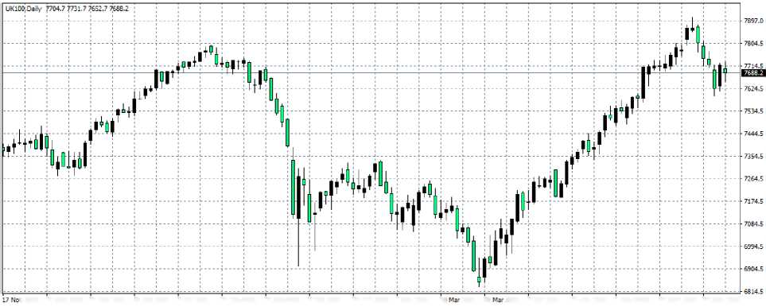

Figure 1: Chart of the daily FTSE 100 stock index, using a candle stick chart pattern.

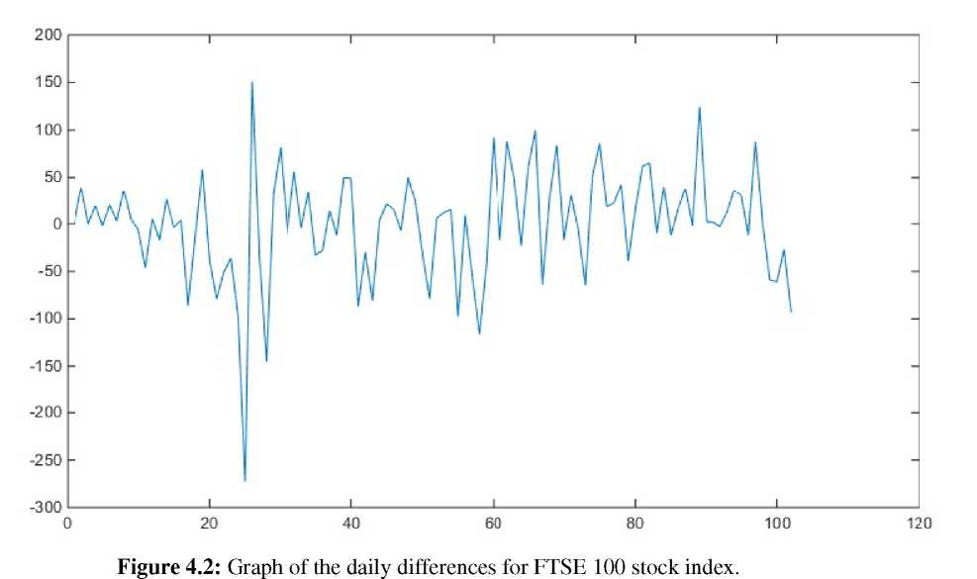

Fig 2- Graph of the daily differences for FTSE 100 stock index

Using the data, we obtained the transition probability matrix for FTSE 100 as:

$P_{1}=\left[\begin{matrix}\begin{matrix}0.000000 & 0.000000 & 0.333333 \\ 0.153850 & 0.153850 & 0.307690 \\ 0.034483 & 0.206900 & 0.068966\end{matrix} & \begin{matrix}0.333333 & 0.333333 \\ 0.307690 & 0.076923 \\ 0.379310 & 0.310340\end{matrix} \\ \begin{matrix}0.000000 & 0.128210 & 0.384620 \\ 0.000000 & 0.058824 & 0.411760\end{matrix} & \begin{matrix}0.410260 & 0.076923 \\ 0.352940 & 0.176470\end{matrix}\end{matrix}\right]$ (4.2.1)

and its stationary or limiting distribution is given as

$\begin{matrix}\begin{matrix}L_{1}=( 0.031214 & 0.138652 & 0.286580\end{matrix} & \begin{matrix}0.375220 & 0.168629)\end{matrix}\end{matrix}$ (4.2.2)

Prediction

Given the initial state vector (0, 1, 0, 0, 0) and since the 102nd day is in state S2. We can also compute the probability vector for the 103rd day as

(0.15385, 0.15385, 0.30769, 0.30769, 0.07692) ,

For the 104th day as

(0.03428, 0.13130, 0.26986, 0.36871, 0.19585)

and for the 105th day as (0.02951, 0.13482, 0.29289, 0.37458, 0.16820).

4.2 Markov Chain Model S & P 500 Index

From the rounded daily closing prices, the differences between successive days were obtained as follows:

$Let d_{k}=f_{k+1}-f_{k}$, where $f_{k}$ is the stock price for the $k^{th}$ trading day, $k=1, 2, 3, …, 101.$

Define the states of the system as follows:

The system is said to be in

$State 1 if d_{k}≤-100$

$State 2 if-100<d_{k}≤-50$

$State 3 if-50<d_{k}<0$

$State 4 if 0≤d_{k}<50$

$State 5 if d_{k}>50$

These were adopted to obtain the time series plots presented in Figures 3 and 4, as well as the transition probability matrix and the steady state distribution.

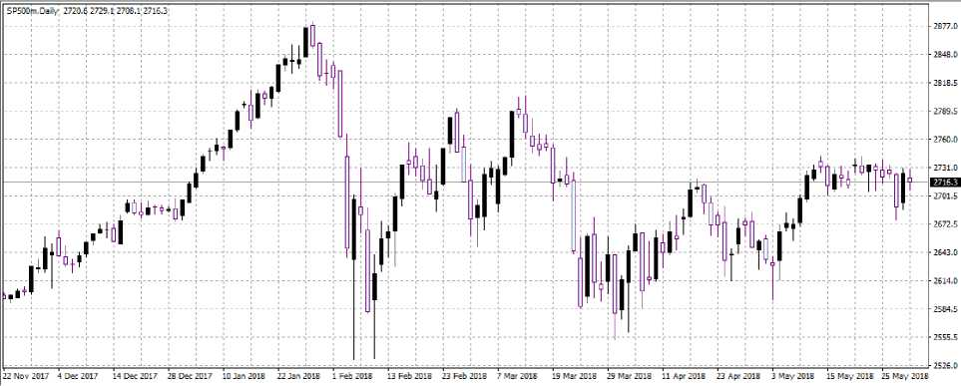

Figure 3: Chart of the daily S&P 500 stock index, using a candle stick chart pattern

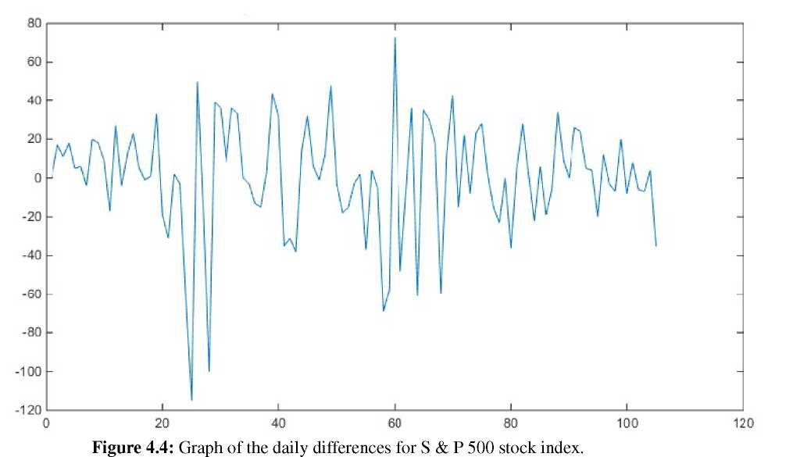

Fig 4- Graph of the daily differences for S & P 500 stock index

The transition probability matrix for S & P 500 is given as:

$P_{2}=\left[\begin{matrix}\begin{matrix}0.00000 & 0.00000 & 0.00000 \\ 0.16667 & 0.16667 & 0.00000 \\ 0.00000 & 0.08108 & 0.35135\end{matrix} & \begin{matrix}0.00000 & 1.00000 \\ 0.50000 & 0.16667 \\ 0.56757 & 0.00000\end{matrix} \\ \begin{matrix}0.00000 & 0.03448 & 0.39655 \\ 0.00000 & 0.00000 & 1.00000\end{matrix} & \begin{matrix}0.56897 & 0.00000 \\ 0.00000 & 0.00000\end{matrix}\end{matrix}\right]$ (4.3.1)

and its stationary or limiting matrix is given as

$\begin{matrix}\begin{matrix}L_{2}=(0.009696 & 0.058178 & 0.364893\end{matrix} & \begin{matrix}0.547966 & 0.019393)\end{matrix}\end{matrix}$ (4.3.2)

Prediction

Given the initial state vector as (0, 0, 1, 0, 0), the probability vector

for the 106th day is given (0, 0.08108, 0.35135, 0.56757, 0.00000) ,

for the 107th day is given as (0.01351, 0.06157, 0.34852, 0.56288, 0.01351), and

for the 108th day, it is given as (0.01026, 0.05793, 0.35918, 0.54885, 0.02378).

4.3 Markov Chain Model for NSE All-share index

The states of the Nigeria Stock Exchange (NSE) index were adjusted to fit the large differences in the daily closing times. Consequently, the following interval definition was used to obtain the respective states:

We thus defined the states of the system as follows:

The system is said to be in

$State 1 if d_{k}≤-500$

$State 2 if-500<d_{k}≤-100$

$State 3 if-100<d_{k}<0$

$State 4 if 0≤d_{k}<100$

$State 5 if d_{k}>100$

These were adopted to obtain the time series plot presented in Figures 5 and 6, the transition probability matrix and the steady state distribution.

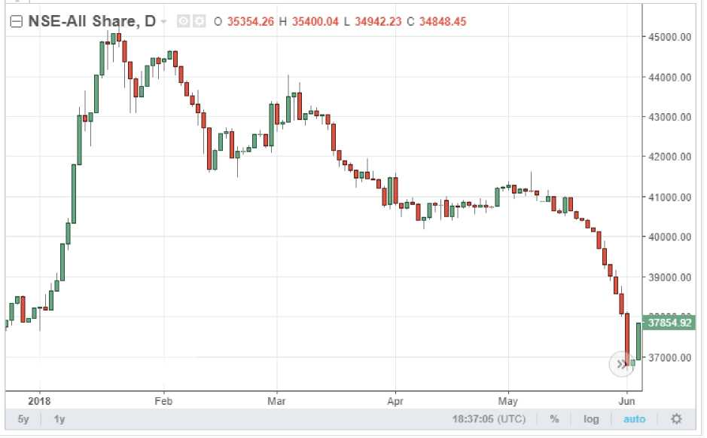

Figure.5 Graph of the daily differences for NSE

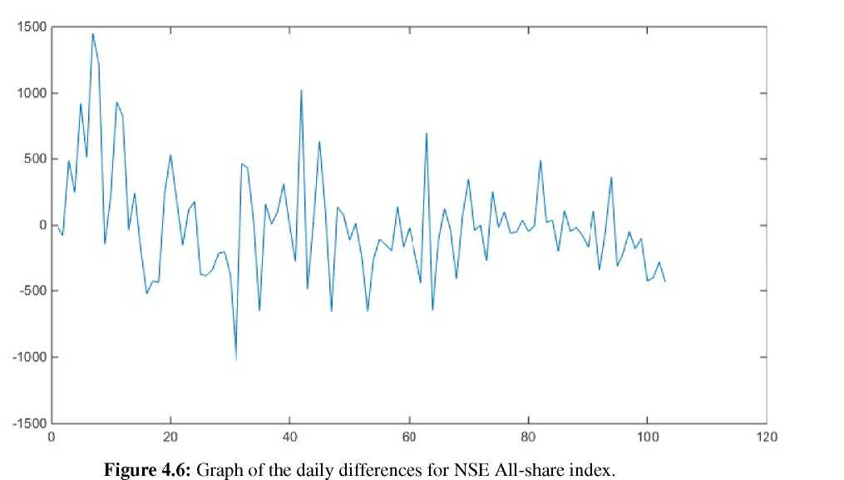

Fig 6- graph of the daily differences for NSE All- share index

The transition probability matrix for NSE All-share is given as:

$P_{3}=\left[\begin{matrix}\begin{matrix}0.000000 & 0.500000 & 0.000000 \\ 0.088235 & 0.411760 & 0.117650 \\ 0.000000 & 0.312500 & 0.250000\end{matrix} & \begin{matrix}0.000000 & 0.500000 \\ 0.088235 & 0.294120 \\ 0.125000 & 0.312500\end{matrix} \\ \begin{matrix}0.153850 & 0.384620 & 0.153850 \\ 0.030303 & 0.242420 & 0.181820\end{matrix} & \begin{matrix}0.076923 & 0.230770 \\ 0.181820 & 0.363640\end{matrix}\end{matrix}\right]$ (4.4.1)

and its stationary or limiting distribution is given as

$\begin{matrix}\begin{matrix}L_{3}=(0.058247 & 0.343326 & 0.156601\end{matrix} & \begin{matrix}0.117861 & 0.324090)\end{matrix}\end{matrix}$ (4.4.2)

Table 1: Stationary distribution for FTSE 100, S & P 500 and NSE.

|  |  |  |  |
| --- | --- | --- | --- |
| State | FTSE 100 | S & P 500 | NSE |
| State 1 | 0.03121 | 0.00970 | 0.05825 |
| State 2 | 0.13865 | 0.05818 | 0.34333 |
| State 3 | 0.28658 | 0.36489 | 0.15660 |
| State 4 | 0.37522 | 0.54797 | 0.11786 |
| State 5 | 0.16863 | 0.01940 | 0.32409 |

Table 2: Interpretation of each market nature in terms of their stability or volatility.

|  |  |  |  |
| --- | --- | --- | --- |
| **Markets** | **Bearish**  **(States 1 and 2)** | **Stagnant**  **(States 3 and 4)** | **Bullish**  **(State 5)** |
| FTSE 100 | 17% | 66.2% | 16.9% |
| S & P 500 | 6.8% | 91.3% | 1.9% |
| NSE | 40.1% | 27.5% | 32.4% |

Table 1 shows the stationary or limiting distribution for FTSE 100, S & P 500 and NSE, while

Table 2 presents the interpretation of each market nature in terms of their sta­bility or volatility, i.e. whether Bearish, Stagnant or Bullish.

**5.0 Discussion**

From Tables 1 and 2, there is an indication that the FTSE 100 was 66.2% stable, S&P 500 was 91.3% stable while the NSE was 27.5% stable. The volatility of FTSE 100 is 33.8%, S&P 500 is 8.7% and NSE is 72.5% .

The actual closing price of FTSE 100 for the 103rd day (30th May 2018), 104th day (31st May 2018) and 105th day (1st June 2018) are 7718.4, 7688.2 and 7707.5 respec­tively. For the first day, the prediction according to the Markov Chain prediction model is that the closing price will fall in state S3 or S4 as both states have the same proba­bilities of 0.30769. This means that the stock will close with a difference that falls in the interval (-50,0) or (0,50), with equal probabilities. Comparing this prediction with the actual price of 7718.4, we observe that the difference between the closing price of the first day and the previous day is 91.8. This shows that it closed with a difference that falls in state S5. On the second day, the price closed with a difference of -30.2. The prediction is that the price will fall into S4, which has the greatest probability in the probability vector for the second day. It should be observed that the price fell into state S3, which has the next greater probability of 0.26986. For the third day, the price closed with a difference of 80.9. Therefore we can also deduce that the prediction with probability of falling into state S4 is close to the actual price.

The actual closing prices for the S $ P 500 is given as 2725.2, 2706.1, and 2734.7 for the next three (3) days respectively. On the first day, the price difference of 34.9 falls into the state S4 whose interval is (0,50). This conformity with the prediction could be due to the fact that the probability of falling in state S4 is greater that 0.5. Observing the prediction for the second day, the difference of -19.1 falls into state S3, which has the second highest probability. For the third day, the state with the highest probability is S4 and the difference of 28.6 from the previous day falls into the state.

On the NSE All-share, given that the closing prices for the next 3 days are 38104.54, 36816.29,36950.98 for 31/05/2018, 01/06/2018 and 04/06/2018 respectively. Their differences are -501.87, 711.75 and 134.69 which falls into states S1, S5 and S5 respec­tively. According to the predictions given by the method used in this paper, there is a very high probability that the prices will fall in to state S2, for the first day. As states S1 and S2 are both in the short position of the stock, the error in the prediction is relatively small. Also, the difference of -501.87 is only a negligible 1.87 lower than falling into state S2. On the second day, the prediction showed a high probability of 0.3293 of falling into state S5, and the price difference for that days falls into that state. For the third day, there was also a high probability of 0.32473 of falling into state S5.

This study has established that the model can serve as a valid method for prediction of the stock prices, and that investors can depend on the model predictions to control investment risks.

6.0 Recommendations

It is therefore recommended that this prediction model be applied to other financial markets like the currency markets, or other stock indices to know which market index it handles best. This model can also be repeated with the indices used in this paper with fewer number of states, say S1 and S2 only, so that the predictions will be easier and a decision will be easily arrived at. Using smaller number of states may ensure a more reliable prediction and better information for profitable trading.

7.0 Conclusion

This study has investigated the use of the Markov Chains model and time series model to predict the price movements of the stock market. The FTSE 100, S & P 500 and NSE All-shares indices were adopted for this investigation because of their sizes and regional importance. It has therefore been concluded that the model works well in the FTSE 100 to give us a bright general idea of what to expect from the stock market. Though the predictions are not totally accurate but it works well with the stock to predict the price movement. In the results of the S & P 500, we observed that the model even works better with this stock as it provided almost accurate predictions because 2 out of the 3 predictions were accurate. For the NSE All-share index, it is safe to say it is 80% accurate in its prediction. As a prediction model that this study represents, it has proved itself to be useful for application in stock markets, but it is not enough for traders to be assured of a profitable trading. This is because stock price movements are influenced by lots of other factors. Hence it should only be used only as an intelligent guess or a confirmatory back up to other methods for analysis of Stock Markets.

REFERENCES

Adekunle, S. A. & Eboigbe, S. U.(2021). Markovian Approach to Stock Price Modelling in the Nigerian Oil and Gas Sector. CBN Journal of Applied Statistics. 12(1): 23 - 43

Agbam, A. S. & Udo, E. O.(2020). Application of Markov Chain (MC) Model to the Stochastic Forecasting of Stocks Prices in Nigeria: The Case Study of Dangote Cement. International Journal of Applied Science and Mathematical Theory. 6(1): 15 - 33

Aghanenu, E. O; Igabari, J. N; Jenije, R. and Arunaye, F. I. (2022). Simulating Models for the Transmission Dynamics of a Novel Corona Virus under the Administration of an Imperfect Vaccine in Nigeria. *Journal of Mathematics and Computer Science. 12:155* <https://doi.org/10.28919/jmcs/7254>. ISSN: 1927-5307

Aparna, B. & Sarat, C. K.(2015). Analysis of Stock Market Price Behaviour: A Markov Chain Approach. Int. J. of Recent Scientific Research. 6(10): 7061-7066.

Bhusal, M.(2017). Application of Markov Chain Model in the Stock Market Trend Analysis of Nepal. International Journal of Scientific & Engineering Research. 8(10): 1733 – 1745.

Das, K. (2024). Fundamentals of Markov Analysis: Theory and Industry Use-Cases. Available at https://www.markovml.com/blog/markov_analysis.

Jose, J. (2022). Introduction to Time Series Analysis and its Applications. Researchgate. Available at https://www.researchgate .net/publications/362389180.

Lakshmi, G. & Manoj, J.(2020). Application of Markov Process for Prediction of Stock Market Performance. Int. Journal of Recent Technology and Engineering. 8(6): 1516 - 1519

Ohwojeheri, O. F., Igabari, J. N. and Tsetimi, J. (2024). A Mathematical Model of Poverty and Cybercrime Dynamics in South-South, Nigeria. Asian Research Journal of Mathematics. 20 (11): 73-85. https://doi.org/10.9734/arjom/2024/v20i11861.

Onwukwe, C. E; &Samson, T. K.(2014). On Predicting the Long Run Behaviour of Nigerian Banks Stock Prices: a Markov Chain Approach. American Journal of Applied Mathematics and Statistics. 2(4): 212 - 215.

Onyemarin, N. N; Ojarikre H. I and Igabari, J. N. (2023). An ARMA modelling approach on infant mortality rate in Nigeria. *Nigerian Journal of Science and Environment. 21 (1): 94 – 114.*

Otieno. S; Otumba. E. O. & Nyabwanga, R. N.(2015). Application of Markov Chains to Model and Forecast Stock Market Trend. International Journal of Current Research. 7(4): 14712 - 14721.

Osemeke, R. F; Igabari, J. N. and Nwabenu, D. C. (2024). Detection and Correction of Violations of Linear Model Assumptions by Means of Residuals. *Journal of Science Innovation and Technology Research (JSITR). 3(9):* E-ISSN 3026-958X. P-ISSN 3027-1169

Sultan, Q; Kaneez, F. & Ahmed, J.(2019). Application of Markov Chain to Model and Predict Share Price Movements: A Study of HBL Share Price Movements in Pakistan’s Stock Market. Bi-Annual Research Journal “BALOCHISTAN REVIEW”. XL(1): 100 – 113.

Tharshan, R. & Arivalzahan, S.(2018). A Markov Model for Investigating the Stock Market Volume Behavior. Journal of Science (Eusl). 9(2): 20 – 38.

Urumese, B. D. and Igabari, J. N. (2023) A Mathematical Model of the Effects of Social Distancing and Community Lockdown on the Spread of Covid-19 Pandemic in Nigeria. *Nigerian Journal of Science and Environment. 21 (1): 156 – 173.*

Vasanthi, S; Subha, M.V. & Thirupparkadal, N. S,(2011). An empirical study on stock index trend prediction using Markov Chain Analysis. JBFSIR.1(1): ISSN 2231- 4288.

Waikhom, R. S; Surendra, K. S. & Jyoti, R.(2017). Application of Markov Chains in Predicting Change in Opening Stock Price. International Journal of Mathematics and its Applications. 5(4)B: 219 - 223.

Zhou, Q. X. (2014). Application of Weighted Markov Chains in Stock Price Forecast­ing. Advance Science and Technology Letters. 53 (ICM 2015): 241 - 244.