Semen characteristics, reproductive hormones and testicular histology of male rabbits fed dietary supplemental levels of dried date palm (Phoenixdactylifera) fruit meal

ABSTRACT
This study investigated the effects of dietary supplementation with dried date palm fruit meal (DDFM) on semen characteristics, reproductive hormone profiles, and testicular histology in male rabbits. Thirty-six grower rabbit bucks aged 8–10 weeks old used for the study were randomly assigned to four dietary treatments in a completely randomized design as follows; T1 (0.00% DDFM), T2 (0.50% DDFM), T3 (1.00% DDFM), and T4 (1.50% DDFM). Each treatment was replicated thrice with 3 rabbits per replicate in a study that lasted 24 weeks. At the end of the experiment, semen samples, blood and testicular samples were collected for laboratory examinations. Results indicated that dietary inclusion of DDFM significantly improved semen volume, sperm concentration, percentage of live sperm cells, and total sperm count per ejaculate compared to the control. Although sperm motility was not significantly influenced (P>0.05), morphological abnormalities decreased in DDFM-supplemented groups. Rabbit bucks in T2, T3 and T4 had higher similar sperm concentration values of 86.67, 92.00, and 92.33 x 10⁶/ml, respectively, than in T1 (77.00 x 10⁶/ml). Hormonal analysis showed increased (P=0.05) follicle-stimulating hormone (FSH) and luteinizing hormone (LH) levels with supplementation, whereas testosterone levels varied among treatments. Testicular histology revealed no pathological changes in the control, while seminiferous tubules in treated groups exhibited varying degrees of hypertrophy, vacuolation, and sporadic germinal epithelial degeneration, particularly at higher supplementation levels. These findings suggest that moderate inclusion of DDFM (1.00%) enhances semen quality and reproductive hormone profiles in rabbit bucks but may induce mild histological changes at higher doses.
Keywords:Date palm fruit, rabbit bucks, semen quality, reproductive hormones, testicular histology, sperm motility, fertility.
- INTRODUCTION
The testis in vertebrates is composed of two primary compartments namely, the tubular compartment and the intertubular (or interstitial) compartment (Schulz et al. 2010). The tubular compartment is made up of the seminiferous epithelium, which contains two cell types, the somatic Sertoli cells and the germ cells (spermatogenic cells), which are present at various stages of development (Matta et al. 2002). The intertubular compartment houses the steroidogenic Leydig cells, blood and lymphatic vessels, macrophages, mast cells, and neural and connective tissue cells. The intertubular compartment is continuous with the tunica albuginea (Koulishet al. 2002; Nobrega and Quagio-Grassiotto, 2007). Surrounding the testicular lobule is the tunica propria, which consists of the basal lamina and peritubular myoid cells (Schulz et al. 2010). The testis is the primary sex organ in the male reproductive system that is responsible for the production of semen.
Semen, according to Frandsonet al. (2009), is composed of spermatozoa suspended in the secretions of the male accessory sex glands. The fluid component of semen, known as seminal plasma, serves as a medium for sperm transport and contains various essential substances, including electrolytes, fructose, citric acid, and sorbitol. Fructose, a sugar molecule, provides a source of energy for spermatozoa. Semen analysis is an essential tool in evaluating male fertility; however, no single semen characteristic is universally accepted as a definitive predictor of fertility (Frandsonet al. 2009). Seminal plasma also contains microparticles of varying sizes that influence sperm function during their journey through the female reproductive tract (Castellini, 2008).The concentration of spermatozoa per milliliter varies between species and is a critical parameter in semen evaluation (Frandsonet al. 2009). Semen analysis has been extensively utilized in the selection of breeding males for both natural and assisted reproductive techniques. Abd El-Azim and El-Kamash (2011), further reported that rabbit breeds exhibit significant differences in reaction time, semen pH, semen density, semen color, mass motility, and progressive motility.
Studies in male rats revealed that the date fruit can improve the process of spermatogenesis, the concentration of testosterone, FSH and LH and sperm (Adaay and Mattar, 2012; Saryono, et al., 2016). Baligaet al. (2011) noted that carbohydrates constitute the primary chemical constituents of dates, encompassing both reducing sugars such as glucose and fructose, as well as non-reducing sugars such as sucrose, along with minor amounts of polysaccharides, including cellulose and starch. A publication by Premium Times (2016), noted that eating dates will promote sperm quality and quantity as it is one of the best natural fruits used for human male fertility and increases the size of testes in men. The article also explained that dates contained high level of flavonoid which aid sperm motility and increase sperm count, help to improve sexual activities and increase the production of sex hormones. Khalifa et al.(2018) in their study, observed that administration of date fruit extracts at 10 and 20 mL decreased nitric oxide and glutathione, increased lipid peroxidation, ascorbic acid and testosterone level and concluded that aqueous extract of date palm could enhance the rabbit buck’s fertility and its health performance. Earlier reports (Arfat, 2014; El-Kashlan, 2015) have demonstratedthat date palm pollen can increase in the level of sex hormones like testosterone, FSH, LH as well as estradiol in experimental subjects by giving DPP to them.Saryono and Rahmanti (2018), stated that date fruit extracts contain a variety of components that work as potent antioxidants such as flavonoids, phenolic, vitamin C, E, and A, which can protect the sperm cell membranes against lipid peroxidation, thus decreasing the percentage of dead sperm and maintain normal sperm morphology.
Hence, this study was designed to evaluate the effect of dried date palm fruit meal on semen quality, testosterone, follicle stimulating hormone (FSH), luteinizing hormone (LH) and testicular histology in male rabbits fed dietary supplemental levels of dried date palm fruit meal.
2. MATERIALS AND METHODS
2.1 Experimental Site
The study was conducted at the Rabbitry Unit of the Teaching and Res. farm, of Department of Animal Science., University of Uyo, Akwa Ibom State. Uyo, the State capital, is located on latitude 4º 59¹ and 5º 04¹ N and longitude 7º 53¹ and 8º 00¹ E, with an elevation of about 60.96m above the sea level, according to Solomon et al. (2024), with a bi-modal rainfall pattern and mean annual rainfall of 2190mm and mean relative humidity of 81%.
2.2 Sourcing and Processing of Test materials
Dried date palm fruits were purchased from a local market in Itu Local Government Area of Akwa Ibom State, Nigeria, and used for the study. The dried date fruits were air dried, milled using an electric grinding machine, and used in this study as dried date palm fruits meal (DDFM).
2.3 Experimental Animals and Management
A total of thirty-six male grower rabbits, aged 8 – 10 weeks, were used for the study. The rabbit bucks were allowed for two weeks of acclimatization period, during which they were fed with formulated ration and Calapogoniummucunoides leaves. Prior to the commencement of the experiment, the rabbits were treated against internal and external parasites by administering ivermectin injection at 0.1ml/rabbit subcutaneously. A broad-spectrum antibiotic (Oxytetracycline L.A) was also administered intramuscularly at 0.2 ml/rabbit to check bacterial load. The rabbits were managed intensively in a wired wooden hutch, located inside an open-ended rabbit house for proper ventilation. The rabbits were provided with feed, water and forages ad-libitum for 168-days (24 weeks) of the experimental period. They were weighed at the beginning of the experiment and subsequently on a weekly basis.
Table 1: Composition of Experimental Diet
Ingredients | T₁  (0.00% DDFM) | T₂  (0.50% DDFM) | T₃  (1.00% DDFM) | T₄  (1.50% DDFM)
Maize | 45.00 | 45.00 | 45.00 | 45.00
Soybean cake | 21.00 | 21.00 | 21.00 | 21.00
Wheat Offal | 17.10 | 17.10 | 17.10 | 17.10
Rice offal | 5.00 | 5:00 | 5:00 | 5:00
Palm Kernel Cake | 8.00 | 8.00 | 8.00 | 8.00
Bone meal | 3.00 | 3.00 | 3.00 | 3.00
Common salt | 0.25 | 0.25 | 0.25 | 0.25
Vit-Premix | 0.25 | 0.25 | 0.25 | 0.25
Lysine | 0.20 | 0.25 | 0.25 | 0.25
Methionine | 0.20 | 0.25 | 0.25 | 0.25
TOTAL | 100.00 | 100.00 | 100.00 | 100.00
Calculated Composition

Metabolizable Energy (Kcal/Kg) | 2806.30 | 2806.30 | 2806.30 | 2806.30
Crude Protein (%) | 17.15 | 17.15 | 17.15 | 17.15
Crude fibre (%) | 5.56 | 5.56 | 5.56 | 5.56
Ether Extract (%) | 6.87 | 6.87 | 6.87 | 6.87

2.4 Experimental Diet
Four experimental diets were formulated to contain dietary supplemental levels of dried date palm fruit meal (DDFM) at 0.00% (control), 0.50%, 1.00% and 1.50% and coded as T₁, T₂, T₃ and T₄ respectively. T₁ contained 0.00% of the test ingredients and hence, serve as the control diet.
2.5 Experimental Design
The four treatment groups were assigned to the four experimental diets in a completely randomized design (CRD). Each treatment was replicated three times with nine (9) rabbits per treatment and three (3) rabbits per replicate. Each replicate received an assigned diet for twenty-four (24) weeks. The statistical model is (cause of replication)
Y_{іј} = μ+Tі +e_{іј}
Where:
Y_{іј} = single observation
μ = overall mean
Tі = Treatment effect
e_{іј} = Random error associated with the jth observation in the ith treatment
2.6 Data Collection
2.6.1 Semen Collection and Evaluation
2.6.1.1 Semen Collection
Semen collection was done using a specially designed artificial vagina (AV) for rabbits. To collect the semen from the bucks, a rabbit doe was introduced to the buck’s cage to serve as a teaser. The buck was watched closely and as it mounts the doe, the AV was placed gently at the vulva of the doe, so as to direct the penis into the AV for penetration and eventual ejaculation.
2.6.1.2 Semen Evaluation
The ejaculates obtained were evaluated according to the method of Zemjanis (1970) adopted by Shinkut (2015). This include visual or gross evaluation of the ejaculate soon after collection for volume and colour as well as microscopic examination for motility, concentration, percentage live spermatozoa and morphological abnormalities.
2.6.2 Testicular Histology
The testes of rabbit bucks from each treatment was removed with the aid of local anesthetic, weighed and fixed in 10% formalin solution for histopathological examination at the Department of Chemo Pathology, University of Uyo. The method of Ewuola (2009) was followed for tissue processing. After fixation, the tissues were dehydrated, infiltrated with liquid paraffin, embedded in paraffin blocks, and sectioned at a thickness of 5 microns. Each section was stained with hematoxylin and eosin (H&E) using standard staining procedures. The slides were examined under a light microscope.
2.6.3 Hormonal assay
Blood sample was taken through the jugular vein from three (3) bucks per treatment into heparinized tubes then centrifuged at 3000 rpm for 15minutes. Serum was separated and stored at -4ºC for analyses. Testosterone, FSH and LH concentration was determined by Enzyme Linked Immunoassay (ELISA) according to the method of (Adeyemi 2014).
2.7 Statistical Analysis
The experimental data were subjected to an analysis of variance (ANOVA) procedure in a completely randomized design, using IBM Statistical Package for Social Sciences (SPSS) version 21. Differences between treatment means were separated using the Duncan Multiple Range Test provided by the software.
3. RESULTS
3.1 Hormonal profile of rabbit bucks fed diets supplemented with dried dates fruits meal
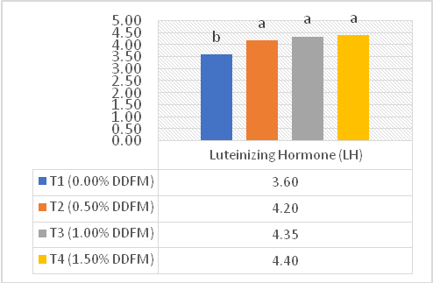
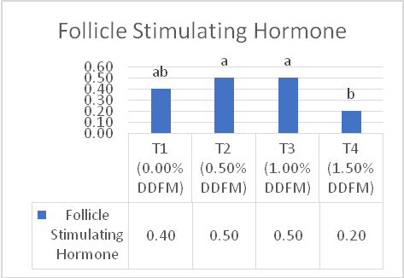

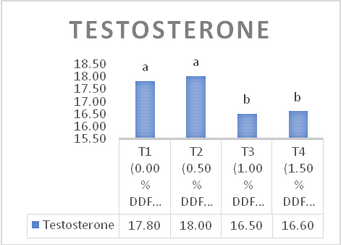

Fig 1-3. Hormonal profile of rabbit bucks fed diets supplemented with dried dates fruits meal

The results one the hormonal profile of rabbit bucks fed diets supplemented with DDFM are presented in figures 1,2, and 3 respectively. These results revealed significant variations in the reproductive hormones evaluated. The result on follicle stimulating hormone showed relative increase in bucks fed T2, and T3 with similar values of 0.50 and 0.50 respectively. These values were however not significantly different (p<0.05) from T1. The FSH value in T1 (0.40) differed from T4 (0.20). The mean values of luteinizing hormone increased significantly (p<0.0) with DDFM supplementation in the bucks’ diets. The mean values observed in the study in bucks with DDFM in their diets were 4.20, 4.20, and 4.40 for bucks in treatments 2, 3, and 4 respectively, bucks in T1 had mean LH value of 3.60. Lower (p<0.05) testosterone was observed in T3 (16.50) and T4 16.60, which differed from T2 (18.00). Treatment 1 had mean testosterone value of 17.80
3.2 Semen characteristics of Rabbit bucks fed diets supplemented with dried dates fruits meal
The results on Table 2 showed that dried dates fruits significantly influenced all semen parameters evaluated except, sperm motility. Semen volume significantly increased (p<0.05) with DDFM supplementation in the bucks’ diets. The mean values in bucks fed 0.50 and 1.00% DDFM 0.73 ml and 0.87 ml. The highest (0.90 ml) semen volume was observed in bucks fed diet containing 1.50% DDFM, while the control group without DDFM in their diet recorded the least mean semen volume of 0.50 ml. There was no significant variation (p>0.05) in the semen colour in the study, as the semen colour milky colour in all treatment groups. Sperm motility was also not affected (p>0.05) by DDFM supplementation in the bucks’ diets. The values observed were 75.67, 84.33, 83.67 and 84.00% for T1, T2, T3, and T4 respectively.

Table 2: Semen characteristics of Rabbit bucks fed diets supplemented with dried dates fruits meal
Parameters | T1  (0.00% DDFM) | T2  (0.50% DDFM) | T3  (1.00% DDFM) | T4  (1.50% DDFM) | SEM
Volume (ml) | 0.50^{c} | 0.73^{b} | 0.87^{ab} | 0.90ª | 0.07
Colour | Milky | Milky | Milky | Milky
Motility (%) | 75.67 | 84.33 | 83.67 | 84.0 | 2.15
Concentration  (x 10⁶/ml) | 77.00^{b} | 88.67^{ab} | 92.00ª | 92.33ª | 2.50
Normal cells (%) | 79.00^{b} | 92.33ª | 92.00ª | 92.33ª | 2.34
Abnormal cells (%) | 21.00ª | 7.67^{b} | 8.00^{b} | 6.67^{b} | 2.34
Live cells (%) | 78.33^{b} | 85.33^{ab} | 89.33ª | 91.00ª | 1.90
Dead cells (%) | 21.67ª | 14.67^{ab} | 10.67^{b} | 9.00^{b} | 1.90
Total cells/ejaculate) (X 10⁶/ml) | 38.07^{b} | 63.87^{ab} | 79.60ª | 83.43ª | 6.78
a b c – Means in the same row with different superscript are significantly different (P< 0.05); DDFM – Dried dates fruit meal; SEM – Standard error of mean.
The supplementation of DDFM significantly increased (p<0.05) the sperm concentration in the rabbit bucks. Rabbit bucks in T2, T3 and T4 had higher similar sperm concentration values of 86.67, 92.00, and 92.33 x 10⁶/ml, respectively, than in those of bucks in T1 with mean value of 77.00 x 10⁶/ml, which was statistically similar to T2. The percentages of normal sperm cells in the semen of the bucks were lower (p<0.05) in the control group (79.00%) without DDFM in their diet, when compared to those with 0.50, 1.00, and 1.50% DDFM in their diets with mean percentages of 92.33, 92.00 and 92.33% respectively. The mean percentages of abanormal sperm cells took similar pattern.
The was significant variation (p<0.05) in the percentage of live sperm cells. Bucks in T1, and T2 recorded similar means of 78.33, and 85.33% respectively, which were lower than those in T3, and T4 respectively with mean 89.33 and 91.00%. Dead sperm cells percentage was significantly reduced (p<0.05) with DDFM supplementation in comparison with those of bucks without the test material. Total sperm cells per ejaculate differed significant (p<0.05) among treatment groups. The mean values were higher in bucks in T3 (79.60 x 10⁶/ml), and T4 (83.43 x 10⁶/ml), which were similar to those in T2 (63.87 x 10⁶/ml), but differ from T1 (37.07 x 10⁶/ml).

4.3: Testicular histology of Rabbit bucks fed diets supplemented with dried dates fruits
meal
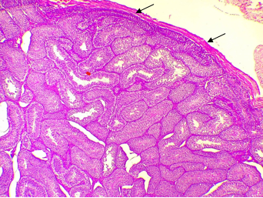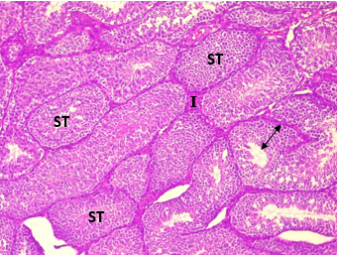

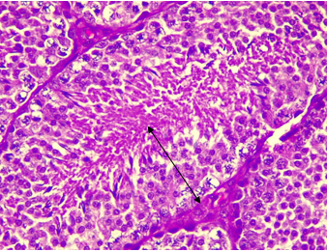

Plate-1 T1: Section of testicular tissue showing tunical albuginea (thin arrow), seminiferous tubules (ST) and the interstices (I). The seminiferous tubules were lined by germinal epithelium (double head arrow). No pathologic changes seen. H&E stain, x40, x100 and x400 magnification.

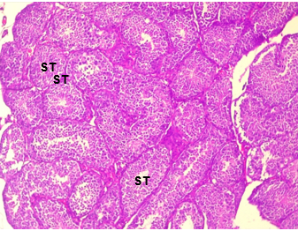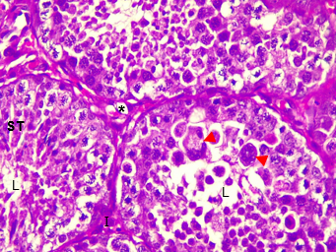
Plate 2 -T2: Section showed seminiferous tubules (ST) and the interstices(I). The seminiferous tubules showed lumen (L) partly &completely filled with both developing and mature germinal epithelial cells. Also seen were hypertrophic and multinucleated cells (red arrowhead) germinal cells. There was focal vacuolation (asterisk) in the interstices. Haematoxylin and Eosin (H&E) stain, x100& x400 magnification

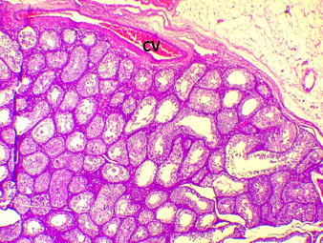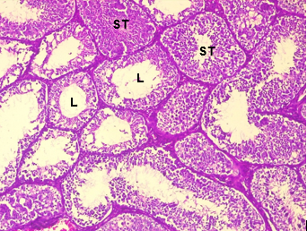

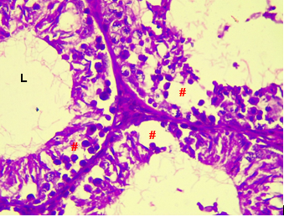

Plate -3 T3: Photomicrograph of testes showing tunica albuginea (Thin arrow) (???) and seminiferous tubules with wide lumen (L), showing and degenerated germinal epithelium layer (#). Haematoxylin and Eosin (H&E) stain, x40, x100 and x400 magnification

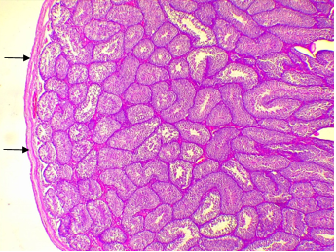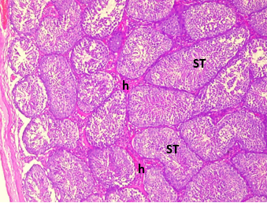

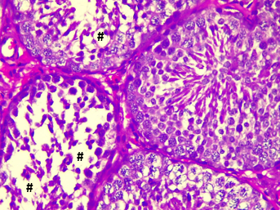
Plate -4 T4: Section of testicular tissue showing tunical albuginea (thin arrow), seminiferous tubules (ST) and the interstices (I). There are sporadic germinal epithelial degeneration (#) in the germinal epithelium of some seminiferous tubule. There are were hyaline degeneration (edema not hyaline degeneration) in the interstices (h). H&E stain, x40, x100 & x400 magnification.
4. DISCUSSION
4.1 Hormonal profile of rabbit bucks fed diets supplemented with dried dates fruits meal
Supplementing rabbit bucks’ diets with dried dates fruits meal significantly increase the luteinizing hormone (LH), follicle stimulating hormone (FSH) and non-significantly at 0.50% DDFM supplementation in the study. This result is similar to the report of Zargaret al. in Khalifa et al. (2018) who found that date extract increased the level of follicle stimulating hormone, luteinizing hormone and testosterone in rats.Khalifaet al. (2018) also observed increase in testosterone level in the blood using date palm extract than control group in rats. This observation is similar with Kostyuket al. in Khalifa et al. (2018), who found an increase in plasma levels of testosterone on eating date palm. Orabi and Shawky (2014) also recorded significant increase in blood testosterone in rats when compared with the control. Pecora et al. (2023) noted that LH acts on the Leydig cells, while FSH acts on the Sertoli cells. Saryono, et al. (2016) explained that Leydig cells are the primary source of testosterone and androgens which have a crucial role in fertility, including sperm production and spermatogenesis, controlling sexual development, and maintaining secondary sexual characteristics and behaviors. Previous studies (Adaay and Mattar, 2012; Saryono, et al. 2016, Zareet al. 2019 and Ubahet al. 2021) in male rats have demonstrated the ability of date fruit to improve the process of spermatogenesis, the concentration of testosterone, FSH and LH and sperm concentration.
4.2 Semen characteristics of Rabbit bucks fed diets supplemented with dried dates
Gross appearance of ejaculated semen is used to evaluate semen for quality (Bearden et al. 2004). The significant increase observed with the supplemental levels of DDFM in the rabbit bucks’ diets is in variance with the findings of Khalifa et al. (2018), who reported non-significant difference in semen volume in male New Zealand white rabbits administered dates water extract at 10 and 20 ml respectively. The semen volume observed were higher than those reported by Solomon et al. (2024) for mongrel rabbit bucks fed diets containing garlic meal. This shows the ability of DDFM to increase ejaculate volume. Earlier report (Campos et al. 2014), put the normal ranges of semen volume between 0.3-0.6 ml, which is below the values observed in the study. The supplemental levels of DDFM however, did not significant effect on semen colour, which were similar to the reports of Solomon et al. (2024) and Solomon et al. (2022) (Solomon et al. (2022) and Solomon et al. (2024)). Good quality semen should according to (George et al., 2017) have a uniformly milky appearance which gives the indication of high sperm concentration. Hafez and Bearden et al. in Ezike (2010) (???) noted that samples with low sperm concentration will appear watery or less opaque.
Semen motility, though did not vary significantly, marginally increased in the DDFM group when compared with the control group, demonstrating the potential of dates to increase semen motility. Sperm cells need energy to swim through the female reproductive tract to the site of fertilitization, therefore the sugars present in dates may have the potential to increase the sperm energy to increase motility. This claim was supported by Shehzad et al. (2021), who stated that the glucose present in dates provides energy, collaborating with the statement of Saryono et al (2016) who started that date fruit contains 50 - 57% glucose. The report of Ubahet al. (2021) sperm motility in rats administered dates extract also supported the findings in this study. Khalifa et al. (2018), who also observed significant improvement in sperm motility in their study stated that sperm motility depends on the synchronized actions of proteins, sugars, ions and small organic molecules, which they said is one of the main factors that facilitate the journey of sperm toward the egg and the subsequent fertilization process. The sperm concentration of rabbit bucks administered supplemental levels of DDFM showed superiority at 1.00 and 1.50% DDFM over the control group, which was however, similar to bucks administered 0.50% DDFM in their diet. Sperm concentration is a crucial parameter in semen quality assessment because, high concentration will increase the number of sperm cells that can fertilize an ovum. This is important because Durape (2007) suggested that though it takes one single sperm to fertilize an ovum, adequate number of spermatozoa must be available at the site of fertilization to ensure high fertility.
The supplementation of DDFM in the diets of the bucks significantly influenced sperm morphology by increasing the percentage of morphologically normal sperm cells and reducing the percentage of abnormal cells. This result on supports the report of Khalifa et al. (2018) who attributed the better result of on (on) sperm morphology in their study to the antioxidant properties of date extract which they said can prevent the superﬂuous generation of free radicals produced by sperm cells, claiming that their ﬁndings supported the obtained results concerning improvement in sperm motility in association with marked reducing sperm abnormality without pronounced effect on sperm livability. According to Saryono and Rahmamati (2016), date fruit extracts contain a variety of components that work as potent antioxidants such as flavonoids, phenolic, vitamin C, E, and A which can protect the sperm cell membranes against lipid peroxidation, thus decreasing the percentage of dead sperm and maintain normal sperm morphology. Date fruit works as an antioxidant to stop the chain reaction due to oxidative stress (Saryono and Rahmamati, 2016).
Live sperm cells percentage increased with DDFM supplementation in the rabbit bucks’ diets with a corresponding decrease in dead sperm cells at 1.00 and 1.50% DDFM supplementation. The results which are synonymous to the report of Ubahet al. (2021), demonstrates the potential benefit of dates on these parameters. This means that DDFM can improve fertility by increasing sperm concentration, percentage of viable (live) sperm cells and reducing the percentage of morphologically defected cells. Live sperm percentage recorded in this study ranged from 71.33 to 85.67% and were similar to those reported by Adeyemi (2014) and Shinkut (2015) for rabbit bucks. This is further supported by the higher significant increase in total sperm cells per ejaculate in the study at 1.00 and 1.50% DDFM supplementation respective. A publication by Premium Times (2016) explained that dates contained high levels of estradiol and flavonoid which aid sperm motility and increase sperm count, help to improve sexual activities and increase the production of sex hormones. Khalifa et al. (2018) concluded that aqueous extract of date palm could enhance the rabbit buck’s fertility and its health performance. Ezike (2010) reported that the volume of ejaculated semen is determined not only for use in processing but also to establish a pattern for individual male. Ejaculates with larger volume, higher concentration, and higher motility will have higher fertility in most cases and more breeding units can be prepared from an ejaculate, thus, reducing the processing time and cost per breeding unit (Ezike (2010)
4.3 Testicular histology
The results on histology showed no pathological changes in the control group. Bucks fed 0.50% DDFM (T2) revealed that the seminiferous tubules showed lumen partly and completely filled with both developing and mature germinal epithelial cells. Photomicrograph of testes in T3 showed tunica albugineaand seminiferous tubules with wide lumen and degenerated germinal epithelium layer. Al Za’abiet al.(2022), observed that the histological structures of the seminiferous tubule in male mice fed dates were normal in all groups, with a complete spermatogenesis process, mature Sertoli cells, intact Leydig cells, and an appropriate percentage of mature spermatozoa. T4 showed sporadic germinal epithelial degeneration in the germinal epithelium of some seminiferous tubule. These findings suggest that higher dose of dates fruit may have slight degenerative effect in the germinal epithelium of some seminiferous tubule due to higher presence of phytochemicals that may have caused changes to the testicular tissues.
5. CONCLUSION
The inclusion of dried date palm fruit meal at 1.00% in rabbit diets can significantly improve key semen characteristics, including sperm concentration, viability, and total sperm count, while reducing sperm abnormalities. Hormonal profiles indicated that DDFM enhanced FSH and LH levels, which are essential for reproductive function. However, histological analysis revealed mild degenerative changes in the testes at higher supplementation levels, suggesting a potential threshold for optimal use.
DISCLAIMER (ARTIFICIAL INTELLIGENCE)
Authors hereby declare that NO generative AI technologies such as Large Lnaguage Models (ChatGPT, COPILOT, etc) and text – to – image generators have been used during the writing or editing of this manuscript.
COMPETING INTEREST
Authors have declared that there is no competing interest among the authors.

REFERENCES
Abd El-Azim, A., and El-kamash, E. M. (2015). Evaluation of semen quality and its relation to mating system for some breeds of rabbits under environmental conditions in the middle of Egypt. Egyptian Poultry Science, 31(II), pp 467–480.
Adaay, M. and Mattar, A. 2012. Effect of Aqueous and Ethanolic Extracts of Tribulus terrestris, Phoenix dactylifera and Nasturtium officinale Mixture on Some Reproductive Parameters in Male Mice. Journal of Baghdad for Science, 9(4), pp.640– 650
Adeyemi, A. A. (2014). Reproductive response of rabbits fed supplemental Moringa oleifera (Lam) leaf meal. PhD Thesis. University of Ibadan, Ibadan, Nigeria.
Al Za’abi, M., Ali, B. H., Ali, H., Manoj, P., Mohammed Ashique, P., Abderrahim N. and Cahl´ ıkov´ L. (2022). The Effect of an Extract and Fractions of Date Pits on Some Plasma Constituents, Reproductive Hormones, and Testicular Histology in Male Mice. The Scientiﬁc World Journal, 1 – 9. https://doi.org/10.1155/2022/4102960
Arfat, Y., Mahmood, N., Ahmad, M., Tayyab, M., Zhao, F., Li, D. J., Shang, P., and Qian, A. R. (2014). Effect of date palm pollen on serum testosterone and intra-testicular environment in male albino rats. African Journal of Pharmacy and Pharmacology, 8(31), 793-800. https://doi.org/10.5897/AJPP2014.4089.
Baliga, M. S., B. R. V. Baliga, S. M. Kandathil, H. P. Bhat and P. K. Vayalil. 2011. A review of the chemistry and pharmacology of the date fruits (Phoenixdactylifera. Food Research International. 44: 1812–1822
Bearden, J. J., Fuquay, J. W., and Willard, S.T. (2004). Applied Animal Reproduction (6th Edition.). Mississippi State University. 183-196.
Campos, A. C. N., Gadelha, C. R. F., Guerreiro, M. E. F., Pereira, E. S., Lima, I. C. S., Linard, M. A. B., Meneses, H. M., Castelo-Branco, K. F. and Estevam, F. N. L. (2014). Male rabbit reproductive physiology. Standard Research Journal of Agricultural Science, 2: 120-128.
Castellini, C. (2008). Semen production and management of rabbit bucks. 9th World Rabbit Congress. Verona – Italy
Durape, N. M. (2007). Physiochemical improve semen quality and fertility. World poultry. 23 (6) 18-20.
El-Kashlan, A. M., Nooh, M. M., Hassan, W. A., and Rizk, S. M. (2015). Therapeutic potential of date palm pollen for testicular dysfunction induced by thyroid disorders in male rats. PloS One, 10(10), 1-23.
Ezike, J. C. (2010). Effect of ejaculation frequency and management conditions on semen quality, fertility and hatchability of local turkeys in the humid tropics. MSc Thesis. University of Nigeria, Nsukka.
Frandson, R. D., Wilke, W. L. and Fails, A. D. (2009). Anatomy and physiology of farm animals seventh edition. Wiley-Blackwell, A John Wiley & Sons, Inc., Publication
George, O. S., Ologbose, F. I. and Akintola, O. A. I. (2017). Sperm characteristics of rabbit bucks fed graded levels of Moringa (Moringa oleifera) Leaf Meal. ScientiaAgriculturae. 20(3): Pp 67 – 70.
Khalifa, A. and El-Sisy, G. and El-Nattat, W. and Mourad, A.A.A. and Maghraby, N. (2018). Effect of water extract of dates palm (Phoenixdactylifera) on semen characteristics and oxidative status in serum of male New Zealand rabbits under heat stress. Asian Pacific Journal of Reproduction. 7(1): 22-26
Koulish, S., Kramer, C. R. and Grier, H. J. (2002). Organization of the male gonad in aprotogynous ﬁsh, Thalassomabifasciatum (Teleostei: Labridae). Journal of Morphology, 254: 292–311.
Matta, S. L., Vilela, D. A., Godinho, H. P. and França, L. R. (2002). The goitrogen 6-n-propyl-2-thiouracil (PTU) given during testis development increases Sertoli and germ cell numbers per cyst in ﬁsh: the tilapia (Oreochromisniloticus) model. Endocrinology 143(3): 970–978.
Nobrega, R. H. and Quagio-Grassiotto, I. (2007). Morphofunctional changes in Leydig cells throughout the continuous spermatogenesis of the freshwater teleost fish, Serrasalmusspilopleura(Characiformes, Characidae): an ultrastructural and enzyme study. Cell and Tissue Research, 329(2), 339–349.
Orabi, S.H.; Shawky, S.M. (2014). Effect of date palm (Phoenix dactylifera) seeds extracts on hematological, biochemical parameters and some fertility indices in male rats. InternationalJournal ofScience Basic and AppliedResearch, 17: 137–147
Pecora, G., Sciarra, F., Gangitano, E. and Venneri, M. A. (2023). How Food Choices Impact on Male Fertility. Current Nutrition Reports, 12:864–876 https://doi.org/10.1007/s13668-023-00503-x
Premium Times (Nov. 8 2017). Eating date fruit increases sexual performance, libido — Experts. https://www.premiumtimesng.com/entertainment/naija-fashion/214751-eating-date-fruit-increases-sexual-performance-libido-experts.html?tztc=1
Saryono, E Rahmawati, E. (2016). Effects of dates fruit (phoenix dactylifera l.) in the female reproductive process. International Journal of Recent Advances in Multidisciplinary Research 3 (7): 1630-1633,
Saryono, Rahmawati, E., Heryanto, Hapsari, ED., Hidayat, A., 2016. Antioxidant enzyme status on rat after date seeds (PhoenixDactylifera) steeping treatment. International Journal of Research in Medical Sciences, 4(6), pp.1893– 1896
Schulz, R. W., de França, L. R., Lareyre, J. J., Le Gac, F., Chiarini-Garcia, H., Nobrega, R. H. and Miura, T. (2010). Spermatogenesis in fish. General and Comparative Endocrinology, 165(3): 390–411.
Shehzad M, Rasheed H, Naqvi SA, Al-Khayri JM, Lorenzo JM, Alaghbari MA, Manzoor MF, Aadil RM. Therapeutic Potential of Date Palm against Human Infertility: A Review. Metabolites. 11(6):408. doi: 10.3390/metabo11060408. PMID: 34205817; PMCID: PMC8235103
Shinkut, M. (2015). Semen characteristics, gonadal sperm reserves and haematological parameters of rabbit bucks fed diets supplemented with Alliumsativum (garlic). MSc Dissertation. Ahmadu Bello University, Zaria: pp 68 – 77
Solomon, E., Solomon, I. P., Istifanus, E. F., Tom, E. T., Eyo, G., Ebe, A. I. (2024). Growth performance and semen characteristics of mongrel rabbit bucks fed dietary levels of garlic (Allum sativum) meal. Journal of experimental and molecular biology. 25 (3): 203-210
Solomon, I. P., Istifanus, E. F. and Idang, E. J. (2022). Effect of frequency of ejaculation and graded dietary levels of Roselle (Hibiscussabdariffa) calyx meal supplementation on sperm profile of mongrel rabbit bucks. Nigerian Journal of Animal Production, 49(3): 162 – 173
UbahS. A.,Agbonu, O. A.,Columbus, P. K.,Abah, K.O., Chibuogwu ,I. C.,Abalaka, S. A.,Abayomi, S. B.,Enem, S. I.,Ejiofor, C. E.,Ajayi, I. E. (2021). Effectsofdatefruit(Phoenixdactylifera)onspermcellmorphologyandreproductivehormonalprofilesincypermethrin-inducedmaleinfertilityinWisterrats. ScientificAfrican11(2021)e00713
Zare, M., Haghpanah, T., AsadiShekari, M., EftekharVaghefi, S.H. (2019). The prophylactic effect of date palm (Phoenix dactyliferaL.) fruit extract on testicular toxicity induced by formaldehyde: An experimental study,” International Journal of Reproductive BioMedicine, 18: 275–286. HTTPS://DOI.ORG/10.18502/IJRM.V13I4.6890

